O2: I am a Social Change Broker - What R U? (Video)
At the SSE Project kick-off meeting it was agreed that practice partners would each make a 5-6 minute video of the story of their social change brokers. These guidelines will help us all create the video footage of our social change brokers through the length of the project. To make this natural, or organic as possible we suggest that all practice partners use the best smartphone or ipad/tablet that they have available. Smartphones/iPad/tablet with a great camera and the ability to record high definition video are no longer difficult to find – in fact they’re everywhere. Professional video content creators are finding that using their mobile phones to shoot video has several major advantages:
- Mobile phones are readily available and we almost always have our phones with us. Quickly and spontaneously capturing video content doesn’t require lugging around large video cameras when an unexpected opportunity presents itself.
- Many apps are available for both iOS (Apple) and Android (Google) mobile devices that extend the functionality of the video camera, provide sophisticated editing and digital effects capabilities, as well as provide a way to immediately upload finished videos for distribution and viewing.

However, while it is good to have a smartphone with an awesome camera, then using a poor video making technique will probably result in a poor video product. Just because you have a very good camera, with all the features money can buy, it doesn’t guarantee that you will create a stunning video without practice and good technique.

Your video does not have to be perfect but following these seven tips, shooting great video with your smartphone will be easy and the footage will look fantastic!

#1 – Good Lighting is Critical
Proper lighting has a huge impact on smartphone cameras because they have smaller image sensors and lenses. Try as much as possible to shoot your video in brightly lit areas. This will help avoid unnecessary shadows and grainy areas in your video. But you also must be careful not to point the camera directly at bright light sources (bright spotlightrs), which will cause unusable overexposed footage and lens flaring. Lighting should be stable and steady; the image sensors in most smartphones do not react to dramatic changes in lighting very quickly. If the light is still making it tough to shoot your video try working with back-lighting and white balance settings if your phone or app provides them. Most phones also offer “touch focusing” in the event your camera is focusing on the wrong area of your composition. After setting the focus on the most important aspect of the video, the automatic exposure control will have an easier time making small adjustments if lighting conditions begin to change.

#2 – Stay Steady
If you don’t want your video footage to come out distorted, blurred, or affected by “rolling shutter” the best thing to do is to keep your phone steady while recording. Use both hands to hold your smartphone as close as possible to your body as you record the video. This can be a bit fatiguing in long takes or sequences and there are others ways to support the phone:
- Stabilizers, tripods and camera cages allow you to keep your smartphone or mobile device still when taking a video with it, they have perfect handles to accomplish this.
- If a smartphone tripod or stabilizer is a little too costly or not practical for you in your circumstances, you can rest your phone on other physical supports like tables, chairs, desks, shelves, use blu-tack to keep it in position etc.

#3 – The Audio Matters as Much as the Video
A good video with poor audio quality is horrible to watch unless you plan to add a completely new audio track “in post” (while editing your video). While you want your video to look good, the quality of your audio is more important than the video, so it should matter as much, if not more. Unfortunately, the built-in microphone in most smartphones (if not all of them) is both low quality and improperly placed. It is very common to catch wind and unnecessary environmental noise that will compete with or drown out any important audio while shooting video outside. This is almost impossible to edit out later. It is advisable to shoot your video in a quiet place, preferably indoors when possible with less ambient noise. Professionals are shooting all sorts of commercial grade videos and feature films using their mobile phones but audio is almost ALWAYS captured with a separate recording device suitable for the job. So, for great quality videos with superb audio, you should get an external recording device or at least a directional microphone that will work with your smartphone. If using an external microphone isn’t possible or practical then stay as close to the audio source as possible and try this little trick: use your hand to cover around the phone’s microphone (but don’t completely cover it). This way, unwanted noise can be reduced, which might give your final video a chance.

As the audio will be in your native language we ask that in the final edit, English subtitles are added at the bottom of the screen to allow the individual to understand the most important bits, the headline and the place where it happened. A full translation is not necessary just the key phrases in English. We also require you to insert a date into the video footage so month/year, Nov 16 (MMM/YY) briefly as a subtitle, this will help anyone from the NA who might review it understand when and where it was taken.

#4 – Get Close to Your Subject
Staying physically closer to your subject ensures better image quality, less digital noise and better focus in your videos since most smartphones use a digital zoom rather than optical zoom.

#5 – Avoid Vertical Video Syndrome (GO Landscape!!)
This is really really important!!!. DO NOT shoot vertical video! Some videographers, who use of their smartphones for digital filmmaking often make the mistake of holding their phones vertically, up and down rather than sideways, while recording.
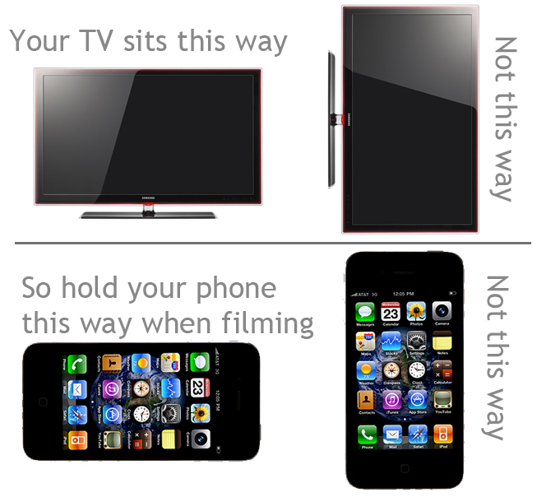
Hold your phone horizontally so that videos played back on other screens (virtually every device including TV) will look fine.

#6 – Be Prepared for the Shoot
Before you begin recording your videos, make sure that you have all of the gear, props, scripts, actors and shooting locations ready to go. Additionally, make sure your phone is charged and that you have enough storage space (available memory) to store the footage – high definition (HD) video files can get large and will drain a battery quickly. So shoot video of your senior social change brokers little and often, lots of short videos say 30-60 seconds over the lifetime of the project can be joined together to create your final 5-6 minute video

#7 – Improve Your Videos with Mobile Apps
The camera app on your smartphone may do a good job but there’s more to video recording than what most of them offer! Some third party apps are very intuitive with great features for those new to developing video content e.g. iMovie while some others unlock professional-like features that might bring out your inner George Lucas/ Steven Spielberg. While you will find some pretty good free apps, investing in a couple of apps that cost a little bit of money can pay huge dividends.

#8 – What Things should we video?
The main focus of this intellectual output are the Senior Social Change Brokers that each practice partner will recruit. So here are some thoughts about the events that should be captured on video:
Recruitment & selection – find a few mins to ask your senior change brokers to answer a few questions about themselves, who they are, what professional and life skills they have, what attracted them to the project, information about the community they want to work in
On Location – Senior change brokers in action in their community – a video of them talking to people in the community, meeting with stakeholders, a senior change brokers own personal thoughts (diary style) after a community meeting (flip the camera on the phone;)).
Broker meetings - Senior change brokers meeting together doing stuff and perhaps their involvement in project meetings
Media opportunities – If you have local media involved with your change brokers (newspaper, radio even TV!) then try and capture some of that on video
Don’t worry if you find you have captured more then 5/6 minutes of total video footage, the idea is to capture as much as possible then to edit it down to 5/6 minutes at the end. For example at University Centre Shrewsbury we expect to capture about 1-2 hours of total video footage over the length of the project.

#9 – Where should we upload our video to?
For now we have created a folder on basecamp called Videos. Could each Practice partner create their own folder and upload all video files to their folder. This will act as repository for now and we can see what video is being captured and monitor it. Remember this is not the final version yet these are the just the short videos we are capturing along the way.

