Local Mors news article:

Volunteers from Aarhus seek inspiration in southern Mors
September 6th 2017
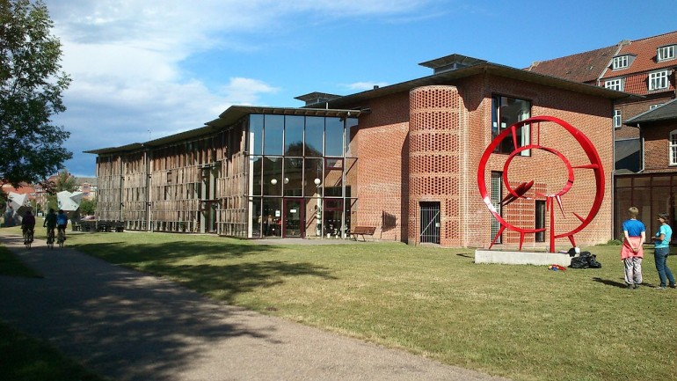
Picture of Folkestedet, one of the community centers run by the Municipality of Arhus
In 2018 Arhus is going to showcase volunteering, hosting the European Capital of Volunteering, and already now active volunteers are looking for inspiration.
Tomorrow a whole bus of volunteers will arrive in southern Mors to hear about Akuthjælperordningen, Strømpehuset, Kulturkøbmanden and Næssund færgen*
The focus of the trip is on how projects are initiated, and the initiators of the trip are three volunteers who have joined a European network of senior social entrepreneurs, which the Municipality of Aarhus participate in. So Aarhus may not be the only one to benefit from the inspiration, also social entrepreneurs in Bulgaria, France, Spain and England may learn from it.
-We can learn a lot from southern Mors, says Kurt Nielsen, who lives both at Mors and in Århus.
-In Århus I meet quite a few persons, especially younger people, who think that absolutely nothing is going on in Mors. They are very wrong. Here you find a long tradition of entrepreneurship and participation in different associations. The four projects that we are going to visit are examples of a remarkable new way of thinking. I am so happy that the people in Mors feel like sharing their experience with us. Just imagine if volunteers in Arhus could run a ferry to Skødshoved or Samsø, says Kurt Nielsen.
The approximately 40 volunteers come from a wide range of organizations such as the community centers in Aarhus, the user councils of the municipality, sports clubs, the DaneAge Association, members of a music band and citizens that are considering becoming volunteers.
-I hope that we will get the opportunity to host a return visit from volunteers from Mors. We have things we want to show them, is Kurt Nielsen’s final remark.
* see the video from the trip

