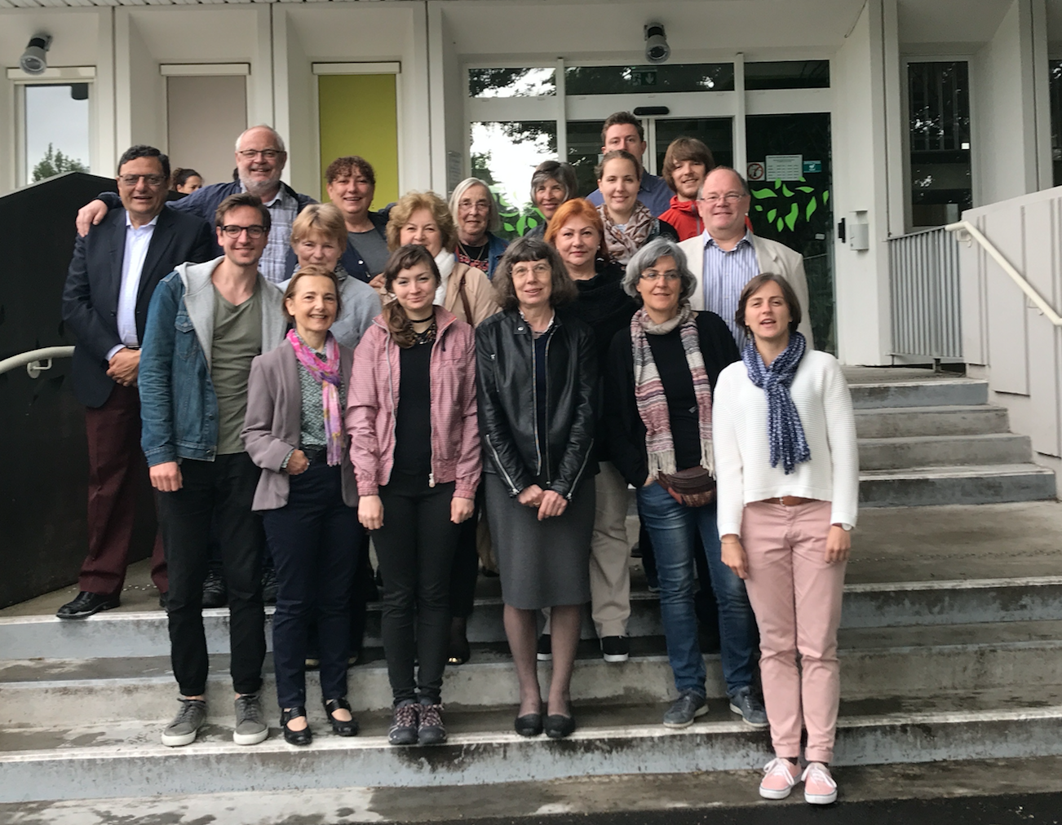
Minutes from Seminar meeting 1 – Week 20 in Pau, France

PROJECT KA2014-2016-001

Project Titel: SENIOR SOCIAL ENTREPRENEURING
Building capacity among seniors to serve as social change brokers in communities

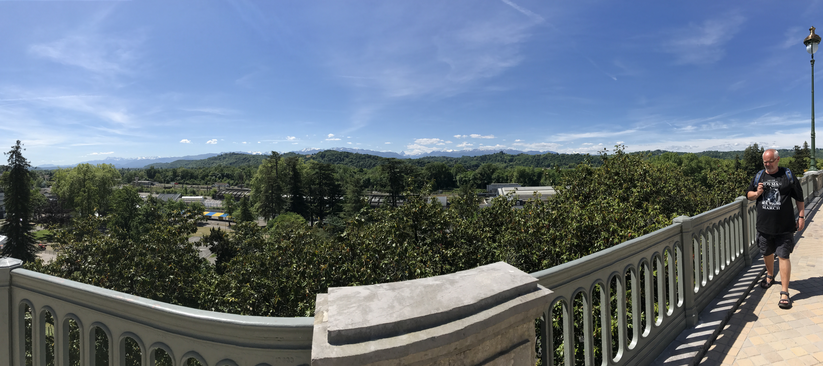
Table of Contents
1
Day 1 – Seminar, Monday the 15th of May 3
1. Introduction 3
2. Presentation 3
3. The scope of the project 4
4. Definition of the term ”Senior Social Entrepreneuring” 4

Day 2 – Seminar, Tuesday the 16th of May 5
1. Short presentation round 5
2. How to take action in communities 5
3. How to work together and form a community of social change brokers 6
4. Plenum dialogues - SWOT 8
5. Discussion in plenum 11
6. Lunch 11
7. Presentation of the IO’s 1-4 11

Day 3 – Seminar, Wednesday the 17th of May 12
1. Jan talks generally about the project from WwE perspective 12
2. Senior social change brokers as MENTORS 12
3. Senior social change brokers as MENTORS - Plenum 13
4. David and Edith went for a trip Wednesday morning – David explains 15
5. Andrea (INRCA) is explaining social change brokering 15
6. Jan explains the definition of social change brokering from the definition in the Practical Guide 17
7. Discussion about documentation 17

Day 4 – Seminar, Thursday the 18th of May 18
1. Brief presentation of the PP’s decision on the portfolio 18
2. How our understanding of the project missions changed? 19

Day 5 – Seminar, Friday the 19th of May 20
1. The seniors thoughts about this seminar 20

Day 1 – Seminar, Monday the 15th of May
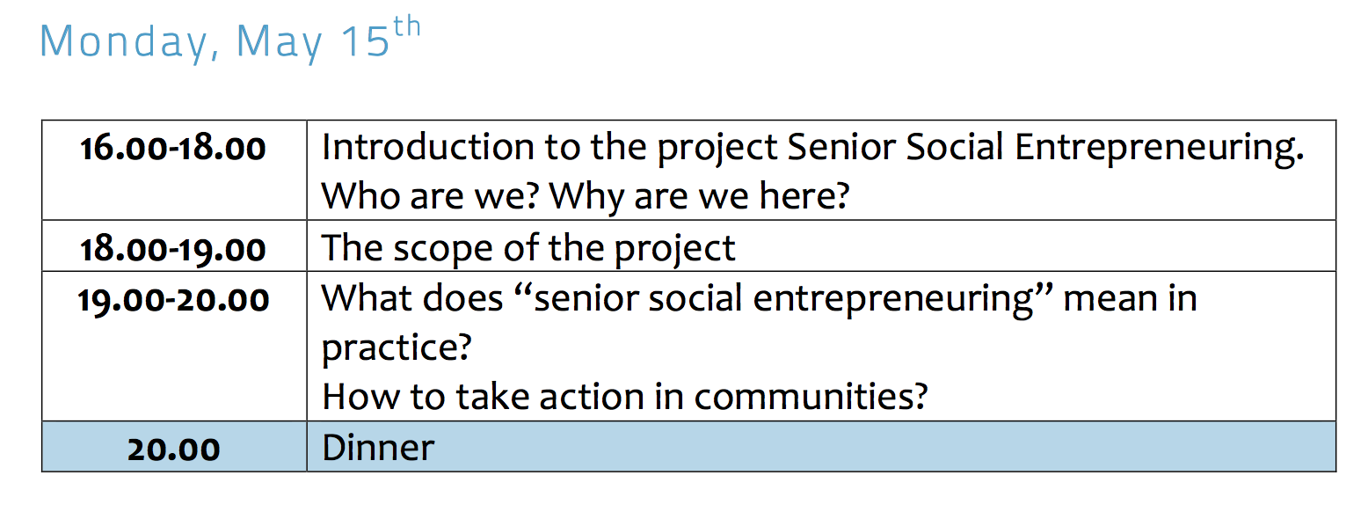

1. Introduction
Jesper briefed shortly everyone why we are in Pau and what we can expect to do while we are in Pau.

2. Presentation
Then we presented ourselves to each other in organisation level and individually. This was done in plenum.

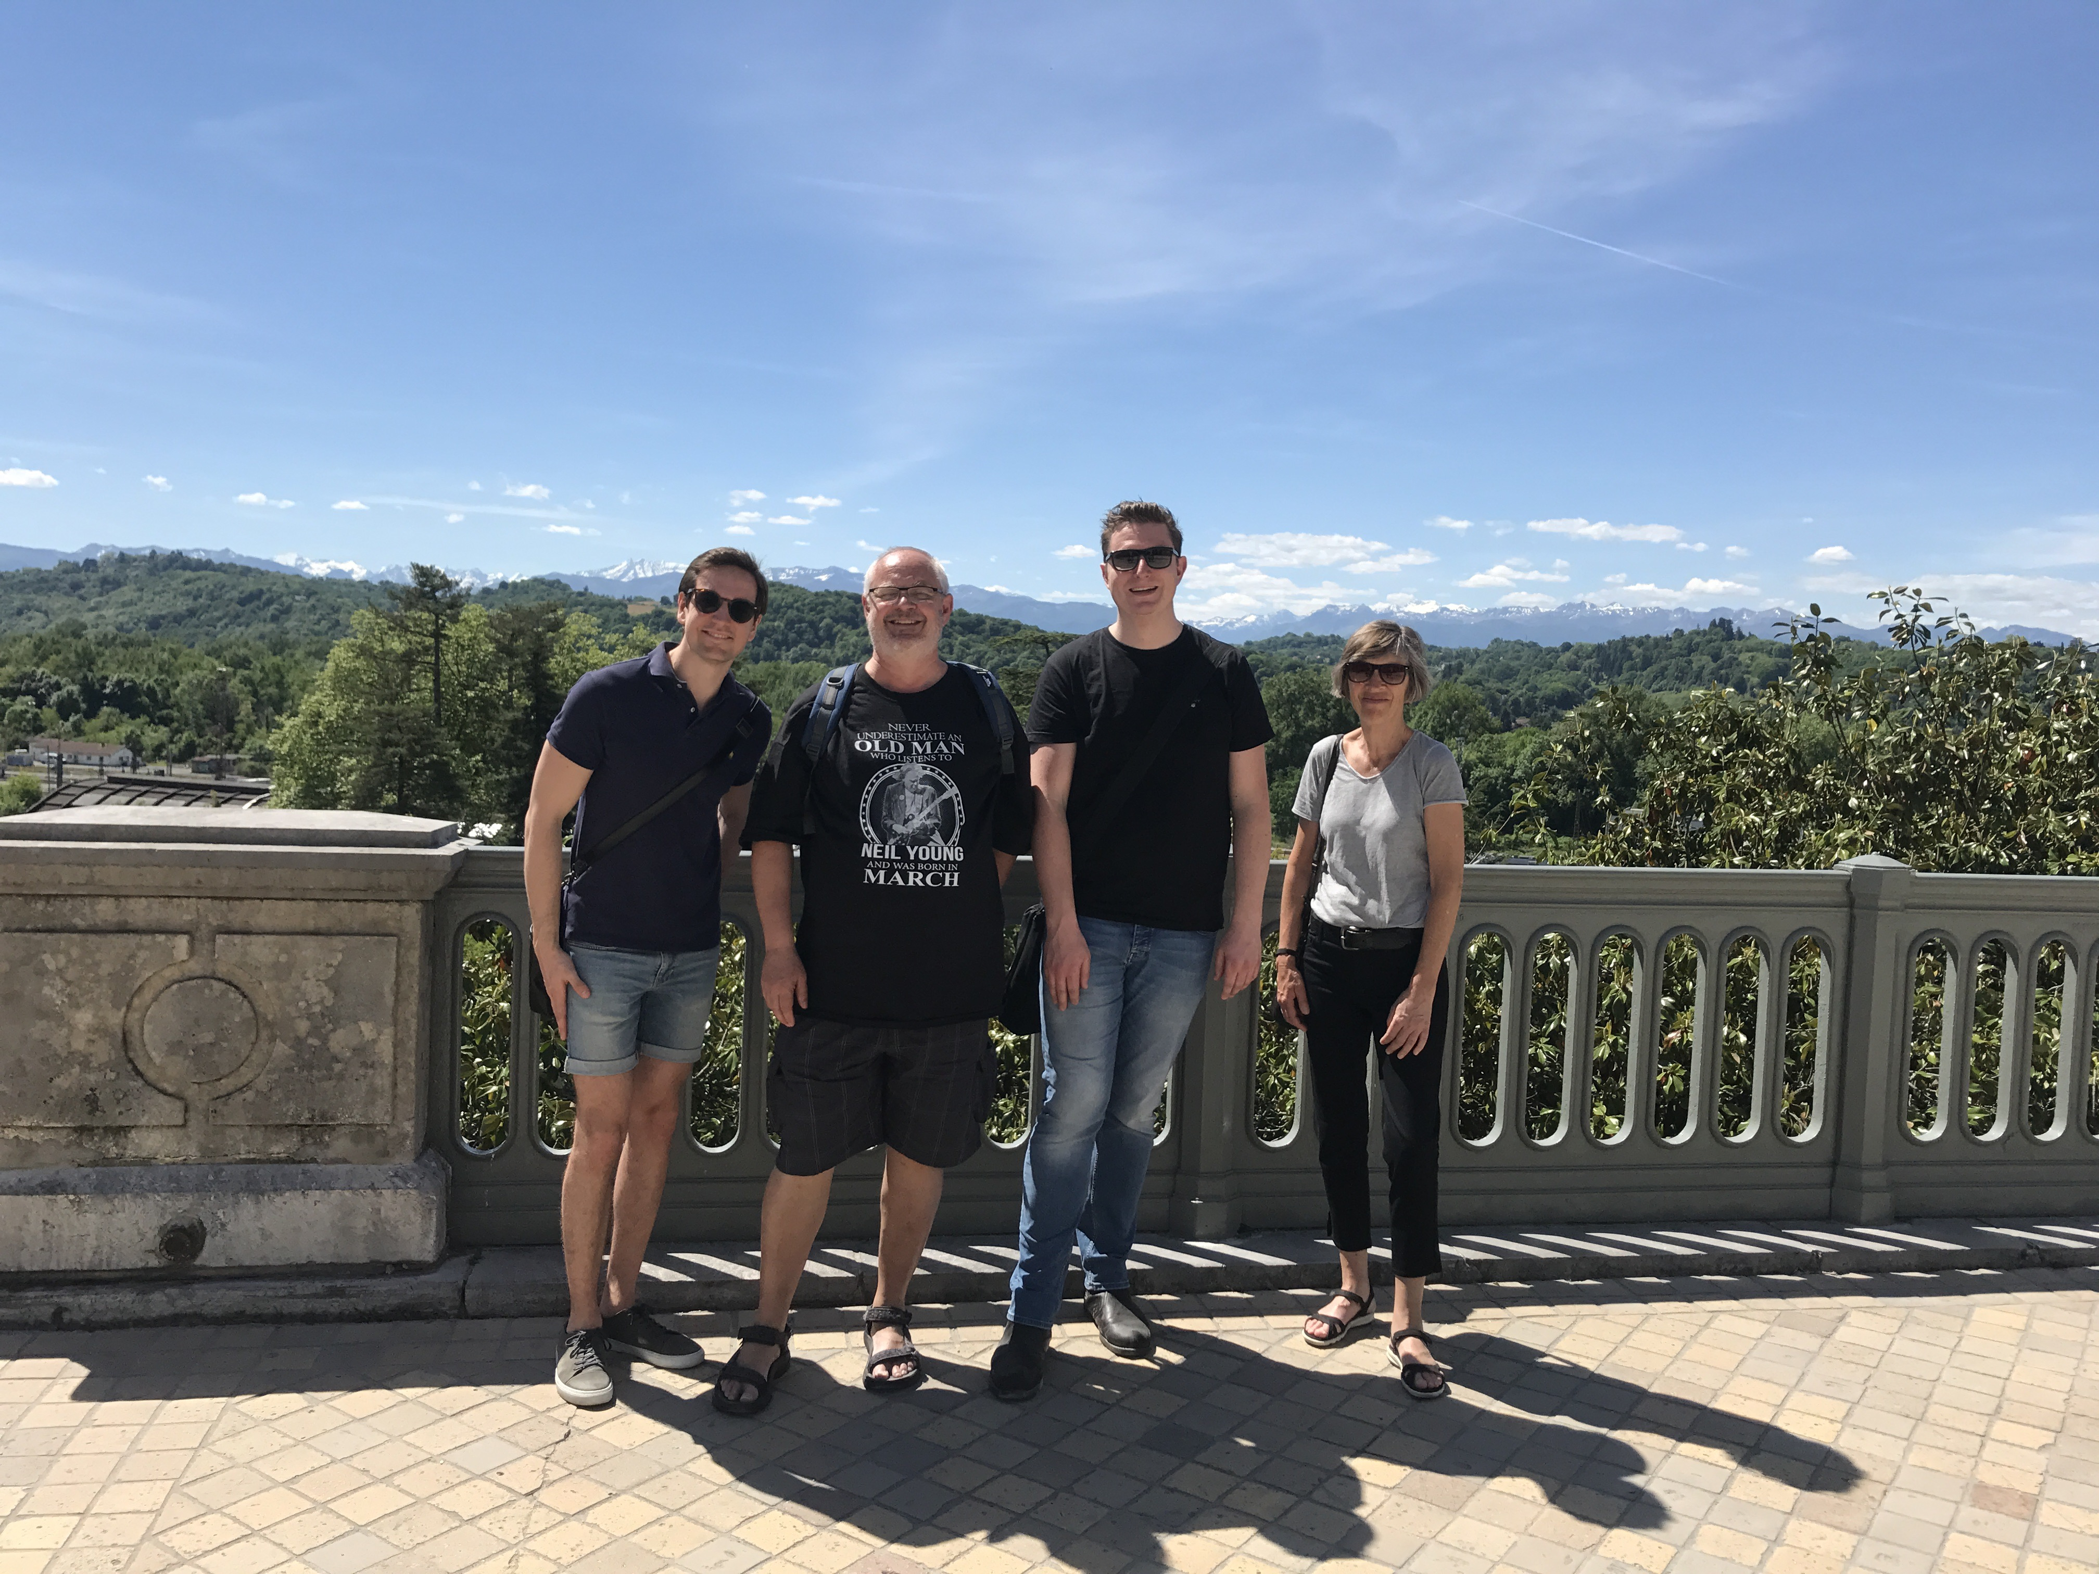
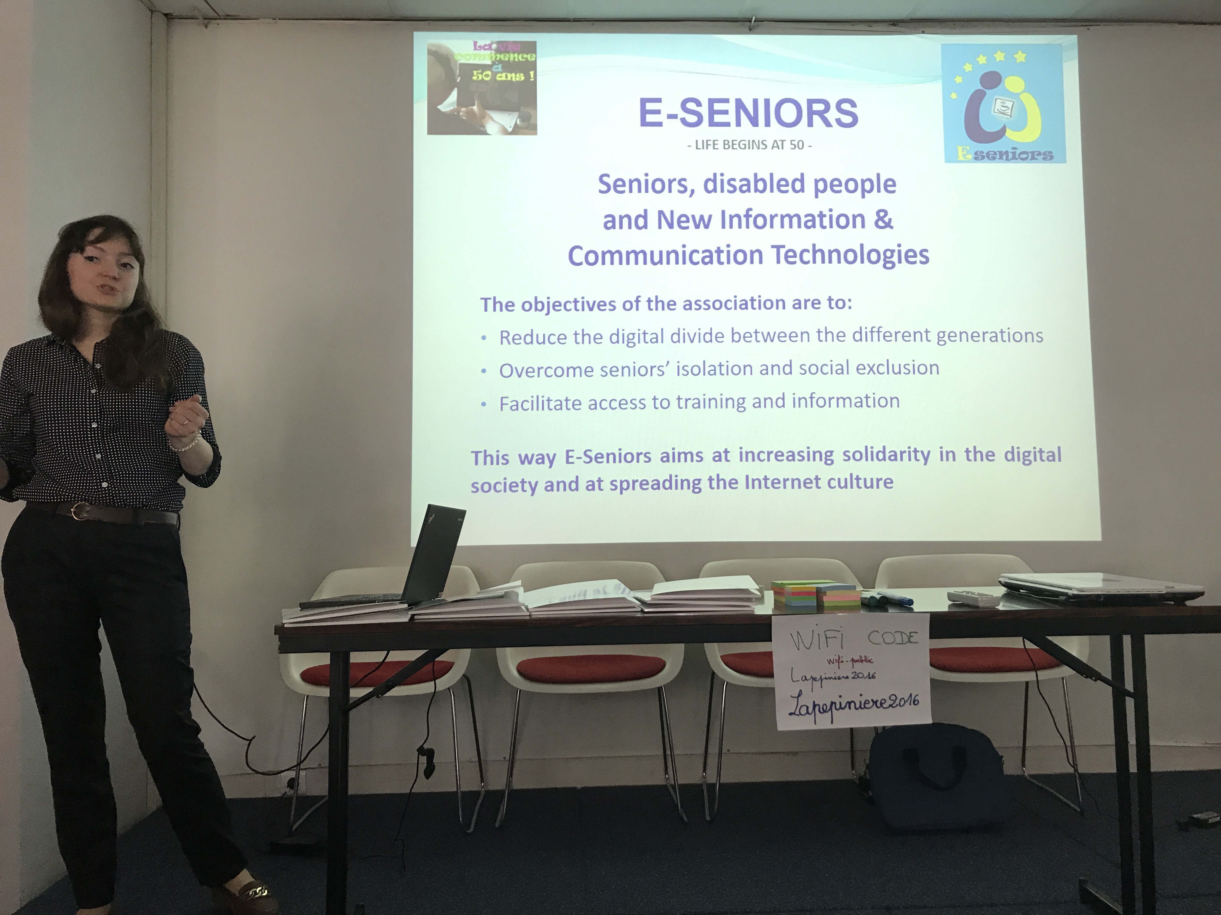

3. The scope of the project
After the presentation, Jesper told the participants a bit about the scope of the projects. What is the purpose and what do we want the seniors to do throughout the project.

4. Definition of the term ”Senior Social Entrepreneuring”
The last thing on the agenda was to define the term ”Senior Social Entrepreneuring”. Lasse from Aarhus Municipality made an overview of the term to the partners and participants and showed examples of social entrepreneuring from Denmark. Edith from Pistes Solidaires mentioned that the term Social Entrepreneuring can be different from each participating country/local community. Therefore Edith thought it was important to understand the differences and each countries way to work with Social Entrepreneuring.

Day 2 – Seminar, Tuesday the 16th of May

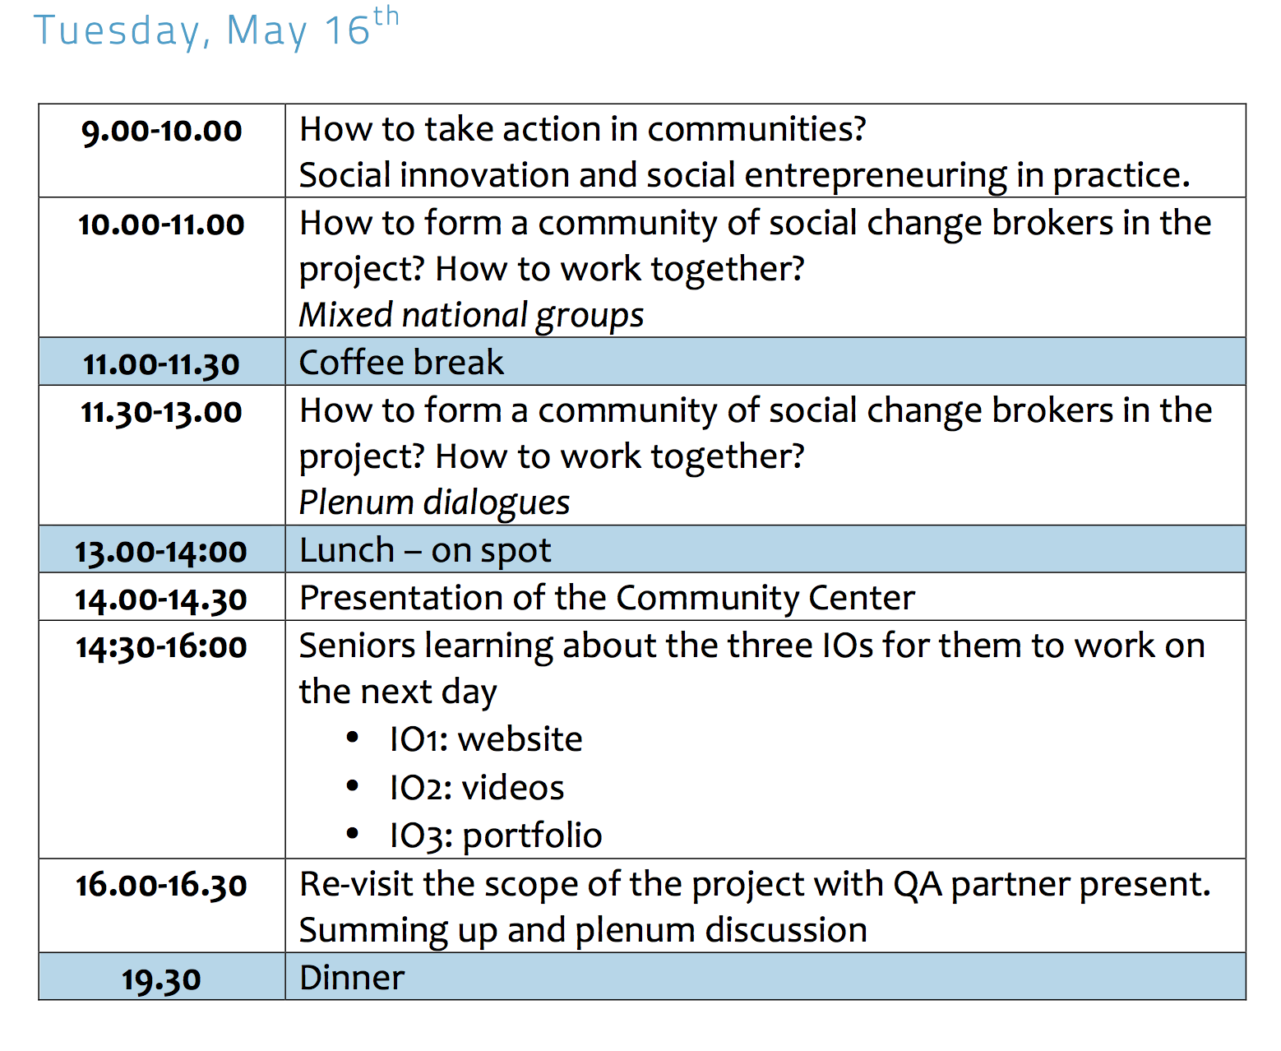

1. Short presentation round
We presented ourselves around the table, because some of the partners weren’t in Pau Monday afternoon.

2. How to take action in communities
Again we discussed the term of Social Entrepreneuring.

It is mentioned that in the Practical Guide we write three bullet points, where one of the bullets says that the seniors have to come up with projects that replaces services who the Municipality would normally take care of.
Marco, Jesper, Tanya and Edith (last one a senior) all agreed that it isn’t meant for the seniors to come up with projects that replaces services, but the perception is different for each country and the social innovation can be a support more than a replacement.

3. How to work together and form a community of social change brokers
The participants was put into groups of 2-3 seniors in each group, so two practice partners were represented in each group.
Afterwards the seniors presented each SWOT from their own local community, for example which strengths and weaknesses the seniors saw in their local community.

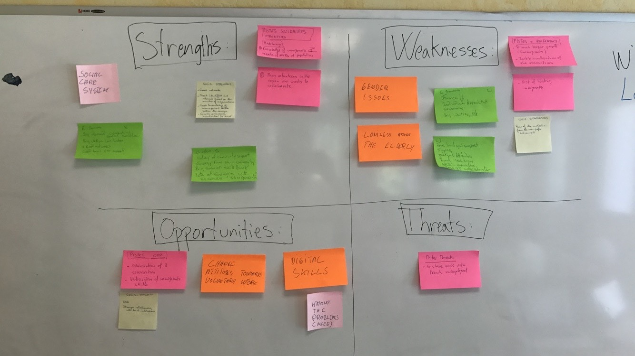

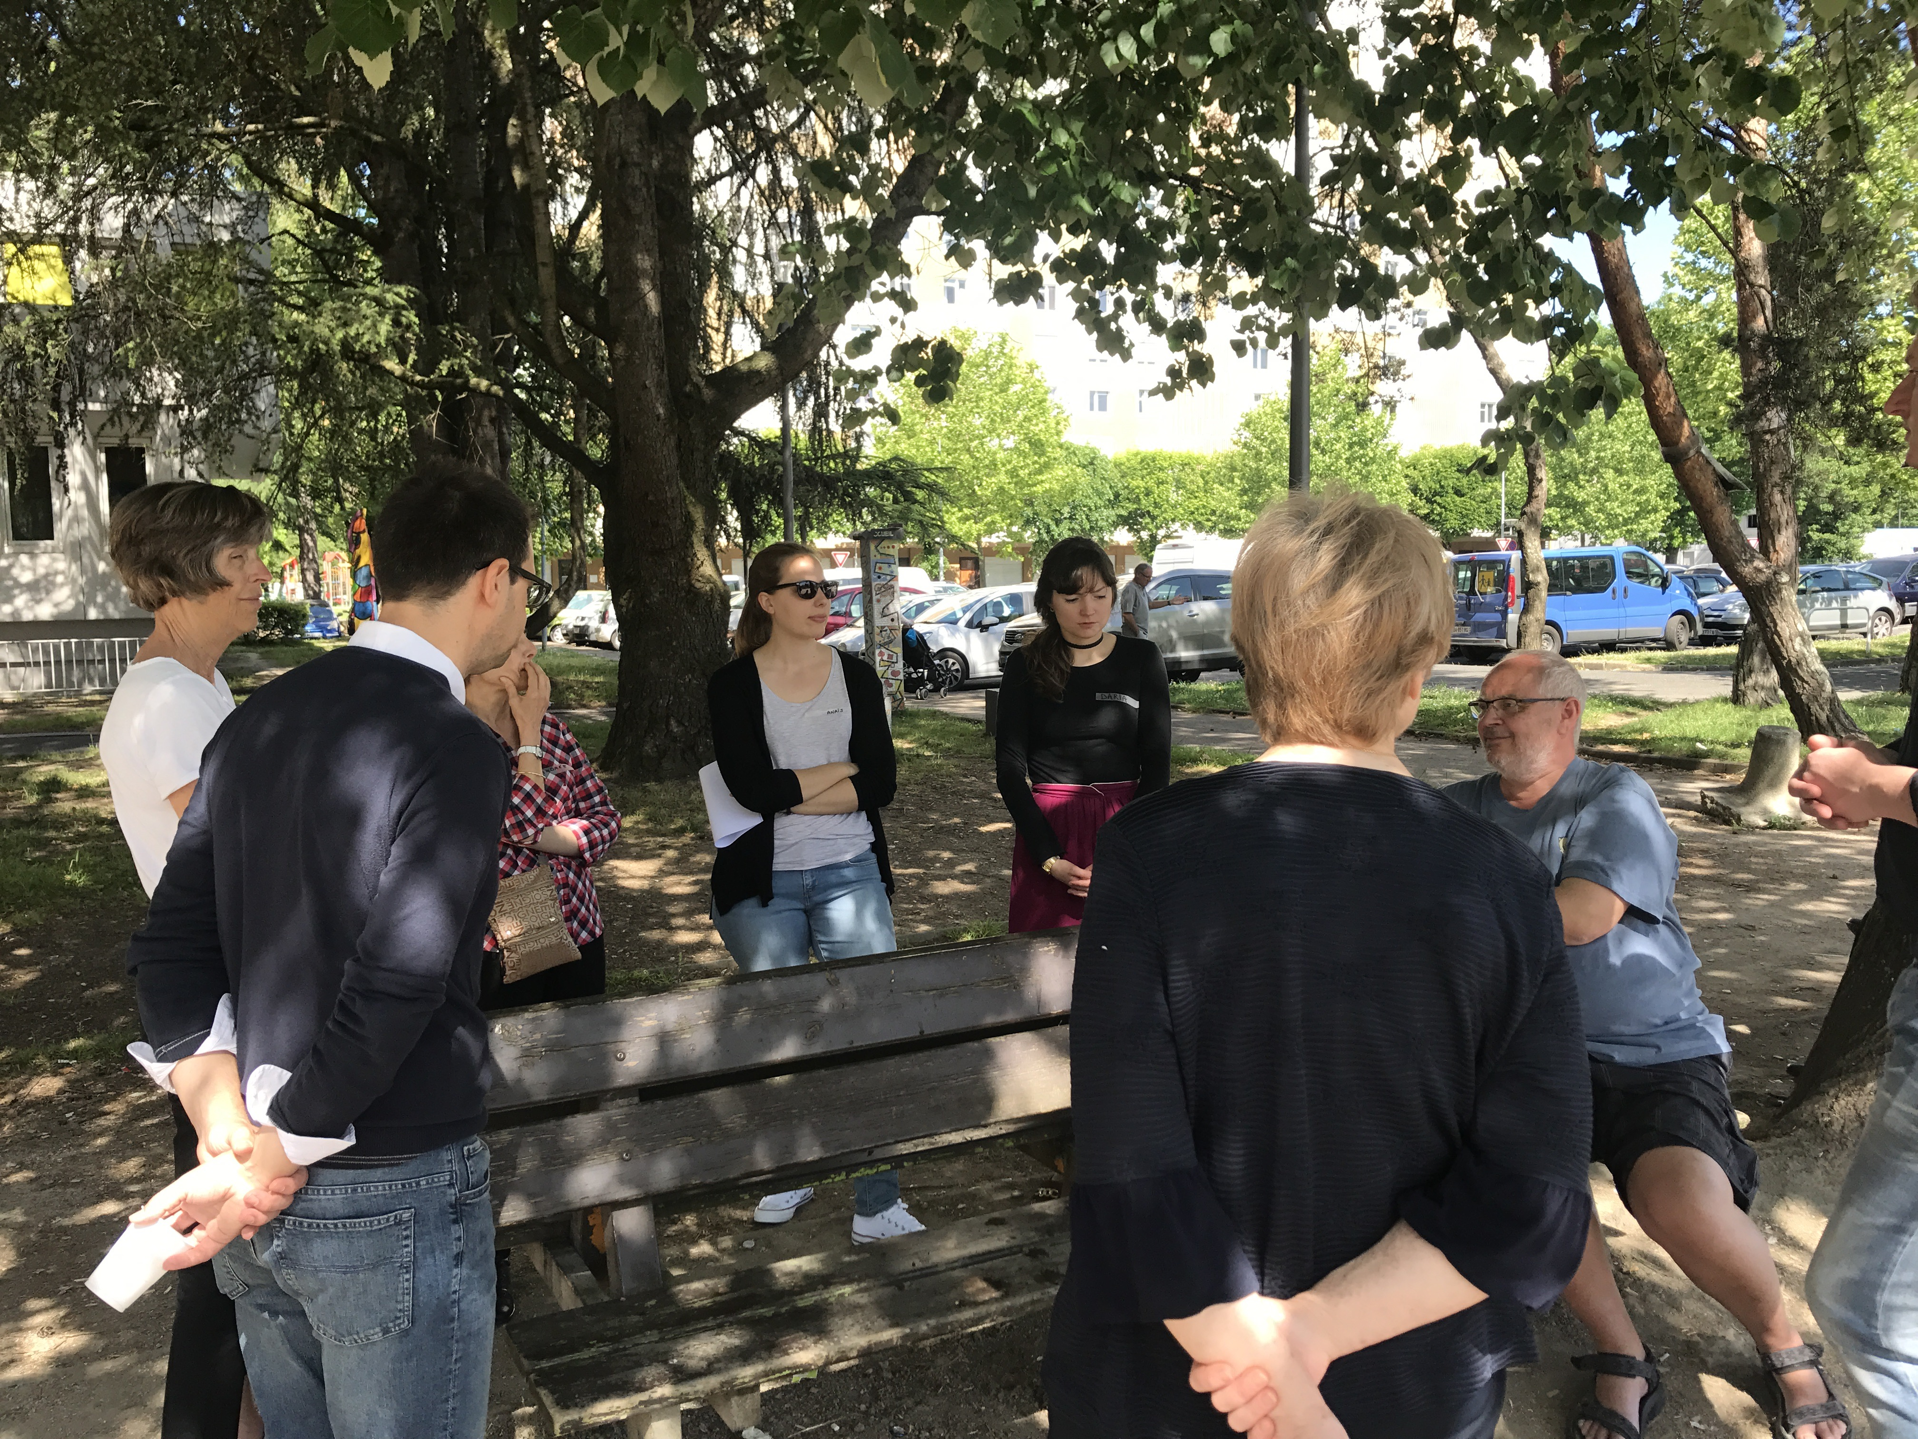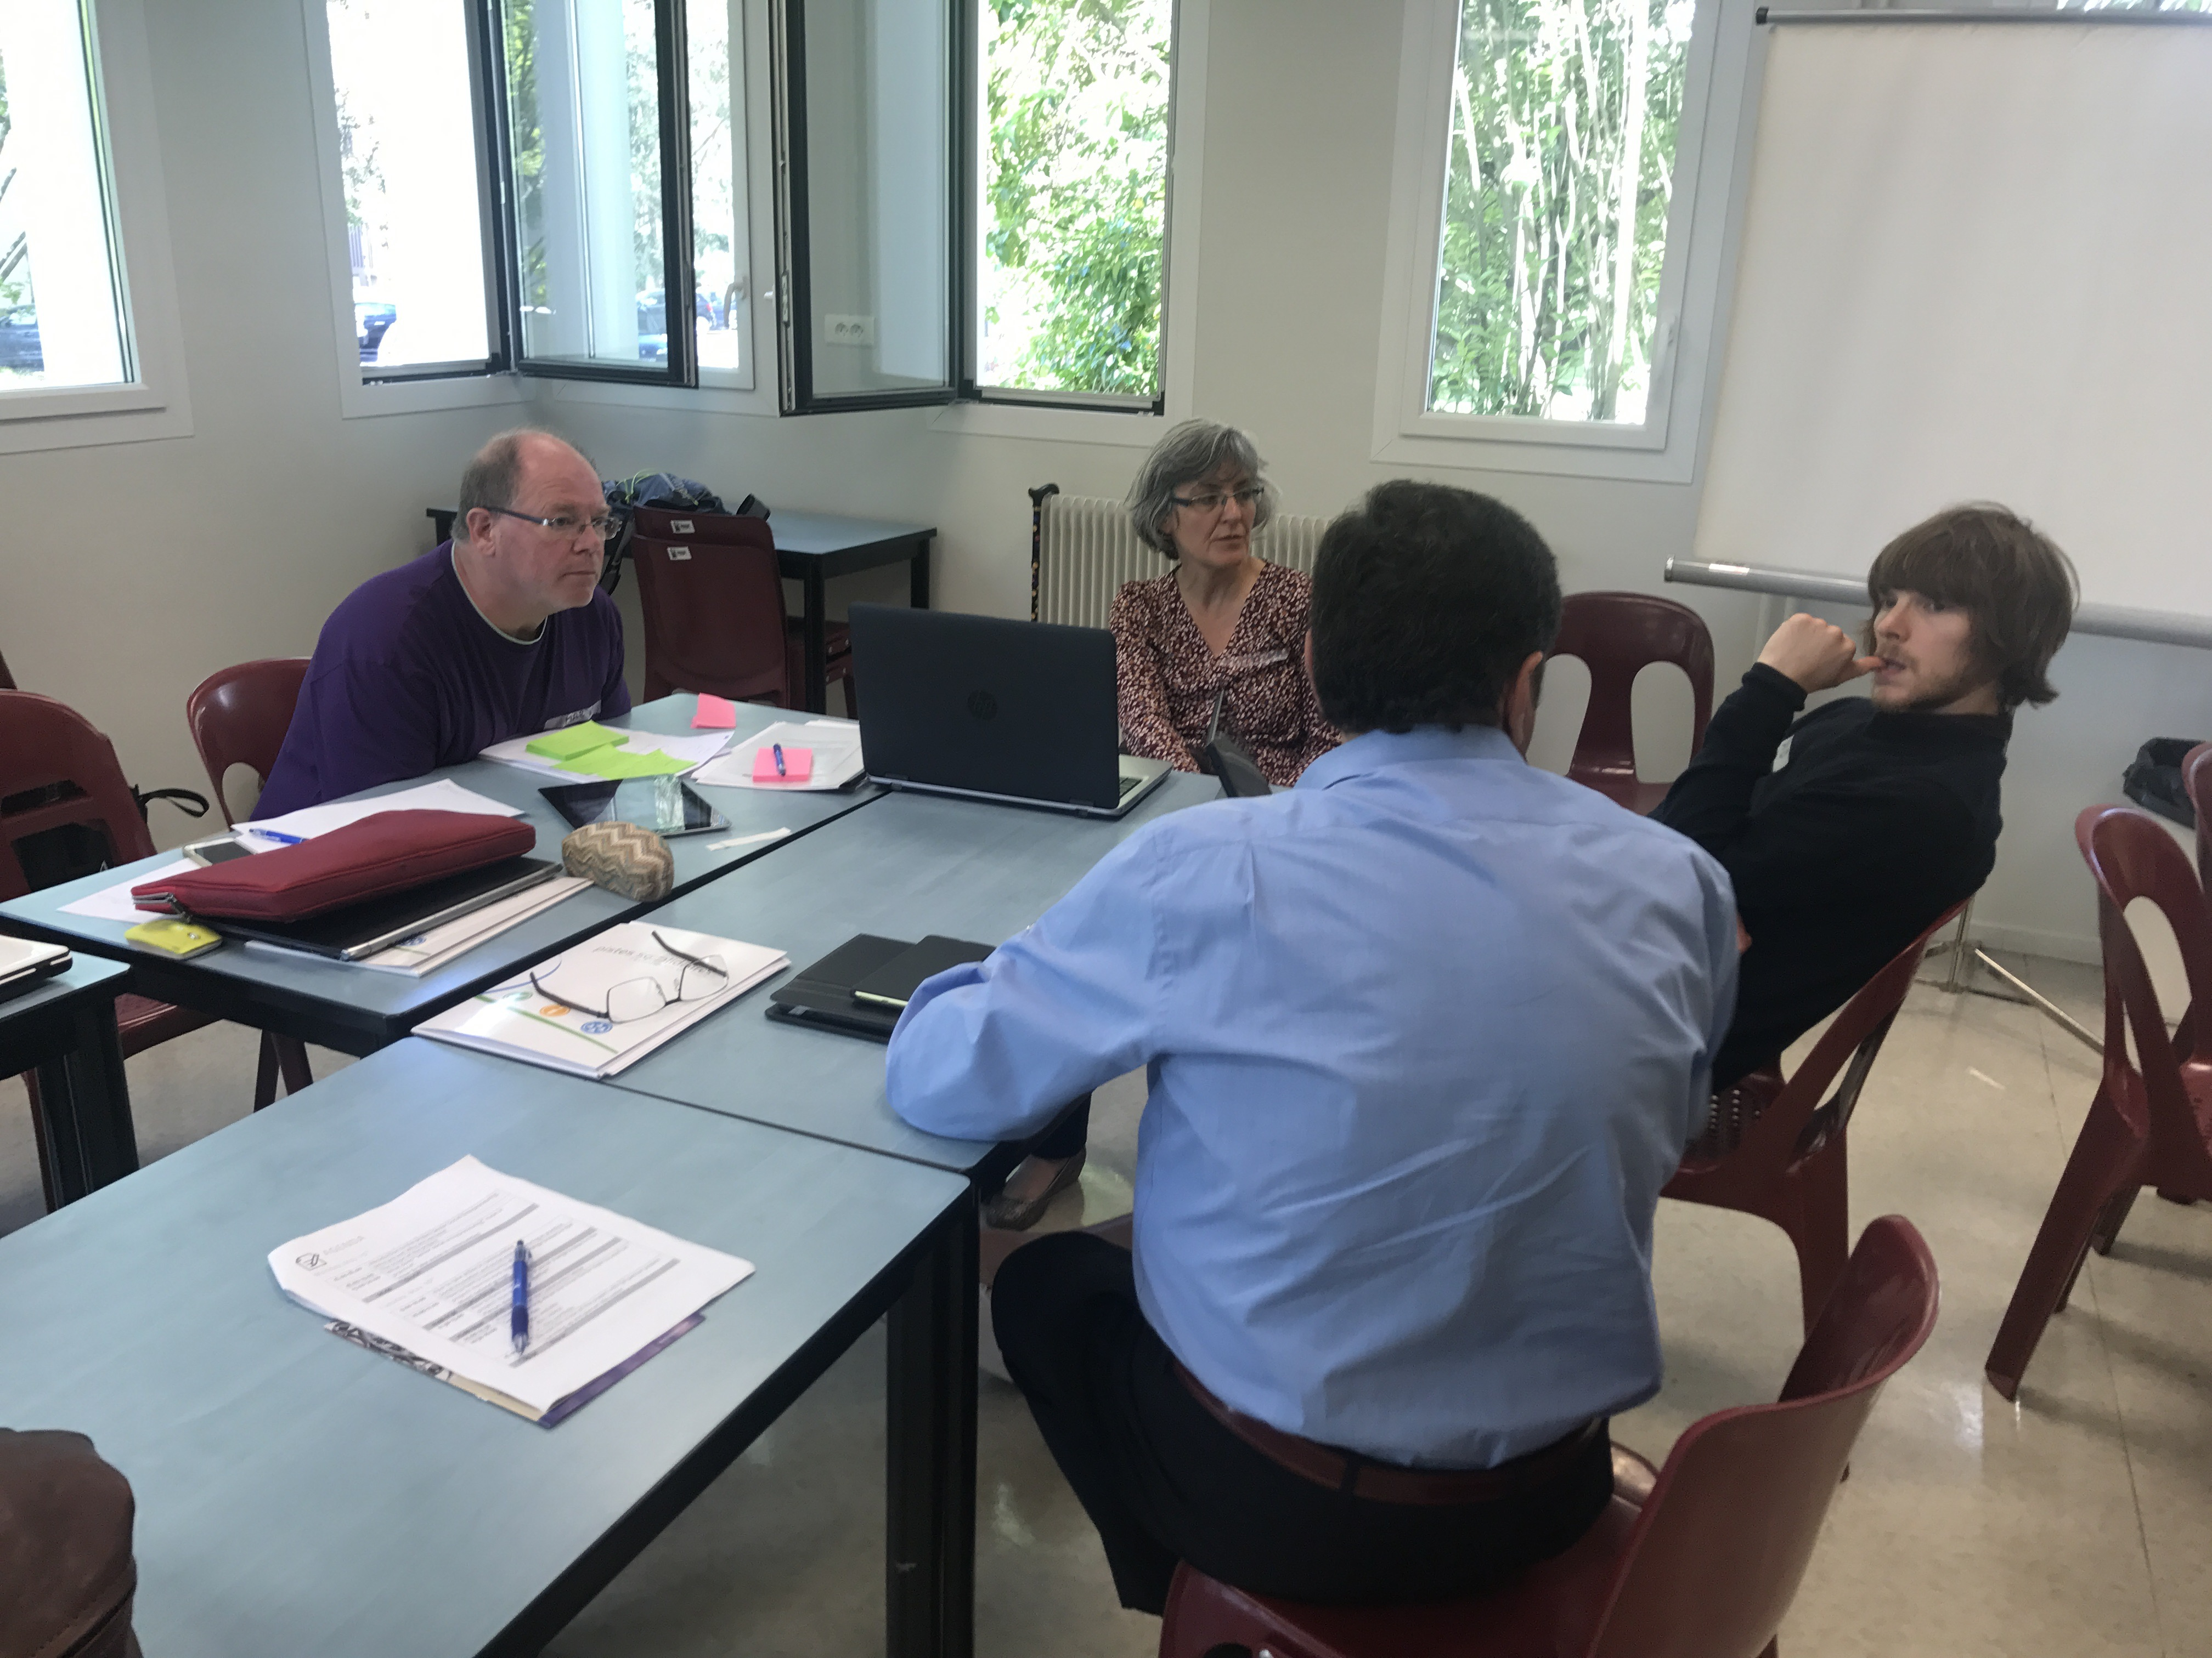

4. Plenum dialogues - SWOT
There were a bit confussion from the seniors and therefore some seniors made the SWOT from a local community perspective and others from a project perspective.
This is what was written down from each partner presentation (Please contribute with more notes if necessary):

Chester
Strengths: Strong community support. People come to Shropshire to retire. Good thing to have a university in the local community. We got skilled people within the county. How do we get these people involved? We got lots of senior with a lot of resources.

Weaknesses: Poor local government support. Within the UK politically it has gone into less service and more contract. The local government has no money or resources to support volunteering and social work.
Political attitude and Laissez-faire.
For examples problems with infrastructure, Internet and food supply.

Opportunities: We need to find a way to get into the skilled-Bank. Use the resources we have throughout the county. Furthermore we should turn ageing into strength instead of weakness.

Threats: Lack of resource, too many demands, the percentage of elderly are rising.

COCIS
Strengths:
1. Good network, how many seniors are able to collaborate with this project?
2. Identify a relevant base, which organisations would like to participate in this workshop.
3. Sustainability

Weaknesses:
Opportunities:
Threats:

E-Seniors
Strengths: A lot of support from the stakeholders. Secondly one of the biggest strengths about E-Seniors is the funder of E-Seniors. She was kicked out of her job and started this organisation about digitalization. A good City to be in (Paris), because of the infrastructure and the size.

Weaknesses: Challenges with seniors being able to use digital tools. Lack of financial support. Loneliness for seniors everywhere.

Opportunities:

Threats:

Association Generations
How can we collaborate between partners? We tried to compare our social systems between Denmark and Bulgaria. We have very different social systems and therefore it is possible difficult to find collaboration in the consultancy area.

Story: Average age of the nurses in Bulgaria – 53 years. Migration of the young specialists. Hired a 72-year old as a nurse, because they don’t have others they can employ.

Strengths: Support for 2 of the seniors ideas coming from the management of the Bulgarian Nursing Association

Weaknesses: Loneliness among the elderly. Lazy men up north – women abroad looking for jobs, how can we put them into action?
We are not teaching, how to be a volunteer through school. The people are not used to work for nothing (no profit). The Municipality are not very involved to support such activities. The municipalities are not against such volunteer activities, but they don’t have resources – financial or human – to support them.

Opportunities: Know the problems now you can take action (mentioned by Kurt, Danish senior).
Perhaps partners could make a project together and travelling to Bulgaria, but mostly Ass. Gen. suggests that we should share experience with each other.

Threats: The Bulgarians are from Associations Generations point of view still missing some laws in the country, for example no law for the volunteers. It is not point of view of GEN, it is a fact that Bulgaria don’t have yet a law for the voluntary work and there are not educational programs connected to the volunteer work in the schools.

Aarhus Municipality
In many ways Bulgaria and Denmark have very different Social Care systems.
Strengths: We have a very good Social Care system on a very high level. Good nursering homes. The elderly has a very strong voice in the society (Elderly board). We have a tradition with volunteer work.

Weaknesses: Loneliness among the elderly.

Opportunities: Sharing experiences with the other partners, regarding the different projects in Denmark. Bring more quality to existing work. We have to develop the skills for the seniors around digital development.

Threats: A change of attitudes about elderly. Perhaps the younger people have to work until they are 75 years old.

Pistes Solidaires
Strengths: Good team in the organisation. Edith is the oldest in the organisation. We are lucky in France to have a lot of organisation.

Weaknesses:

Opportunities: The funding that the organisation has. The definition of Social Entrepreneuring in France is “common good” and the economy is for the people and not for the country.

Threats: Policy, we have more than 50 % who wanted to leave EU or change the organisation.

5. Discussion in plenum
Marco is mentioning, how important it is to be clear, which collaboration that can be made and how you can be inspired by each other.
Areas mentioned: Refugees, IT, young people mind-set about seniors, loneliness among seniors.

Making a platform for sharing information about projects throughout the Senior Social Entrepreneuring. So we can learn from each partner and come up with great ideas to our own local community.
Marco is mentioning that documentation is important to inspire other partners.

6. Lunch
Working with Europe arrived after lunch.
Afterwards we got a presentation of the Community Center from the Community Centers deputy director.

7. Presentation of the IO’s 1-4
Lasse (Aarhus Municipality) walked the partners and seniors through the website in a short presentation.
Then David (University of Chester) described IO2 (video material) to the seniors. There weren’t any questions in particular concerning video and website.
Next E-Seniors represented by Anäis explained the seniors about the portfolios. Here the seniors have concerns with the amount of documentation. This was a big topic at Wednesdays meeting. See minutes for Wednesdays meeting for more information.
At last Marco made a short presentation of IO4 just so the seniors understood the meaning of IO4 and what the documentations means for the policy paper.

Day 3 – Seminar, Wednesday the 17th of May

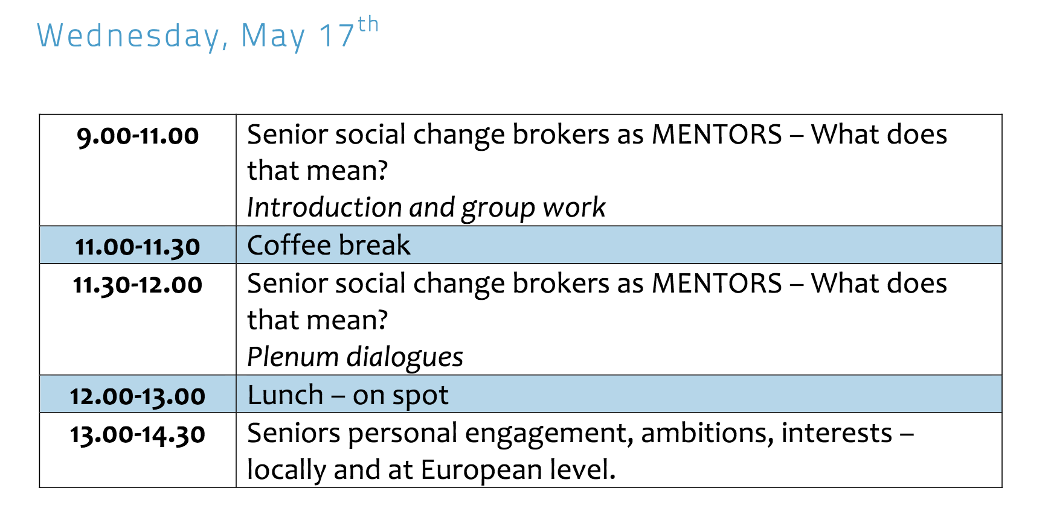
Jesper started the day by going through the agenda.

1. Jan talks generally about the project from WwE perspective

Jan mentioned that it doesn’t look like we have done much senior social change brokering yet. He thinks that we should talk about a new timeline for the project on the partner meeting.
Jan said that mentoring should be postponed until the senior social change brokering has been done.
He thought that the seniors should go into the project and inspire others instead of waiting to see, what they can be inspired of. The seniors need to be brave and be the pioneers.

Jan also said: “Entrepreneurship only works without a security belt on and you have to be out of your comfort zone”.

2. Senior social change brokers as MENTORS
Jan is presenting the point of senior mentoring (see WwE slides about senior mentoring on Basecamp).

3. Senior social change brokers as MENTORS - Plenum
Group 1
Bulgaria: The professional community of the nurses in Bulgaria was chosen to be involved in this project because their average age is 53 years. A problem with the nurses. Part of them don’t have digital skills.
Small village, more of the people aged 60+, they need a centre for social contacts.

Aarhus: Kurt told the group about his engagement in a Tennis club. How do we involve seniors in Tennis? They got 50 seniors to meet up on the tennis court at the middle of the day. They went on Tennis trips to Mallorca and Turkey etc.

Group 2
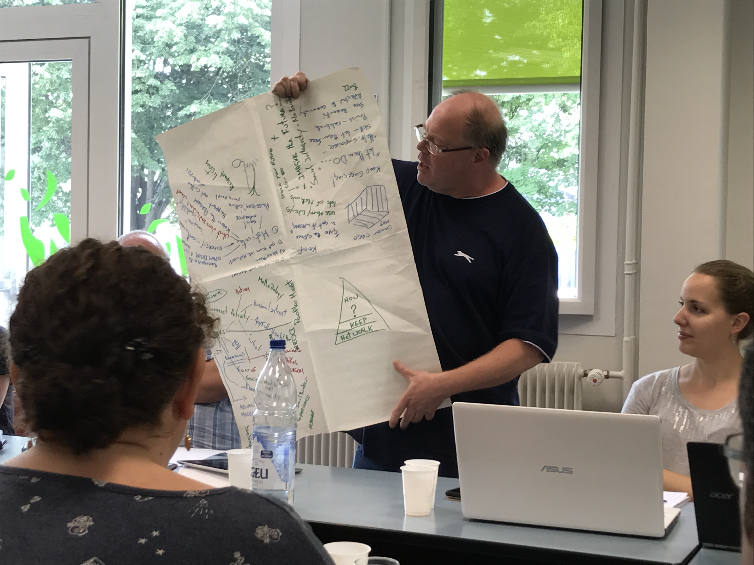
How do you capture your seniors?
What is our motivation?

Don’t spend all the energy knocking on door. Find the people that are interested in the project.
Focus down on the individual. At the end of the day we are all motivated by different things. What will get me out of bed in the morning?
For Mark (Senior from Chester) the project is about keeping him engaged.
Anthony (senior from COCIS) thought it was important to know how to find the proper people and spend your energy right.

Should the projects be about seniors? Not necessarily, also put in the young people.

Second question:
How will you mentor seniors?
We have the freedom to do what we want. Mark (senior from Chester) mentioned that our whole life we had a boss, but now we are free to decide for ourselves.
Give seniors the space to make things wrong!
Mark is using an example about when he learned to walk. He fell a lot, but learned to walk in the end. The process was disappointing for others.

The group also mentioned how important it is to share the experiences in each local community.

The group also talked about the word “hygge”, which is a Danish word that is difficult to capture, but it’s leaning against cozy. The group thinks it is important to remember the times, where it was cozy and comfortable, and how do we put that into play in the project.

Group 3
Moira (a senior from E-Seniors) explains the group work.

Seniors have experienced and can bring that into action.
Retired is such a “bad” word. Instead Moira likes the Spanish word for it. It is more cheerful.
What are we doing on this earth? We have the time to put things together and create.

What is our reason to get up in the morning?

Ann (Senior from Chester) lives in a small village in England. In the area where Mark, Ann and David are coming from, they have started rebuilding the community.

Ann mentioned that she has a friend with Parkinson disease. She doesn’t think she is a social change broker for driving her friend to the hospital. Lasse came along in the group work and explained, how all Parkinson diseased people don’t necessarily have family or friends that could drive them to the hospital. How can we help these diseased people and make a project out of it?

The group has troubles understanding the definition of social change brokering. They want to get a closer look on the definition of the term.

Moira says that Mark from group 2 mentioned a very important word: Recognition. To recognize the seniors as resourceful human beings should be an important part of the agenda.
Why do you just let the seniors go, when they are retiring?

Change the mentality: What can seniors do for themselves, instead of what can we do with them.
Quote from poem: We are the ones; we’ve been waiting for.

4. David and Edith went for a trip Wednesday morning – David explains
80 families are a part of this activity. There are people of all ages. They have small gardens, where they can get food supply and bring home with them three days a week.

5. Andrea (INRCA) is explaining social change brokering
Social change brokering is about finding a social need and pursue, not necessarily reach, but try to find a solution that brings social value to the local community.
We need to document in a very simple way, what the seniors experienced along the way. It is the pathway between the need and the solution.

Kurt: One of the discussions in our group was that we shouldn’t just discuss it in the group. Instead we have to act. Try out pilot projects and allow it to fail.

Tanya: A basecamp to share and inspire each other is important in the process of projects.

Mark: It has been a bit of an anxiety for me. I have made my project for a year. Is it enough documentation I have made – Mark isn’t sure?

Andrea: Document should be very simple. INRCA just need a couple of lines. The documentation is just to tell the story. Or else we can’t tell the story. It is a very basic document. For example: which issues, challenges and successes have you experienced?

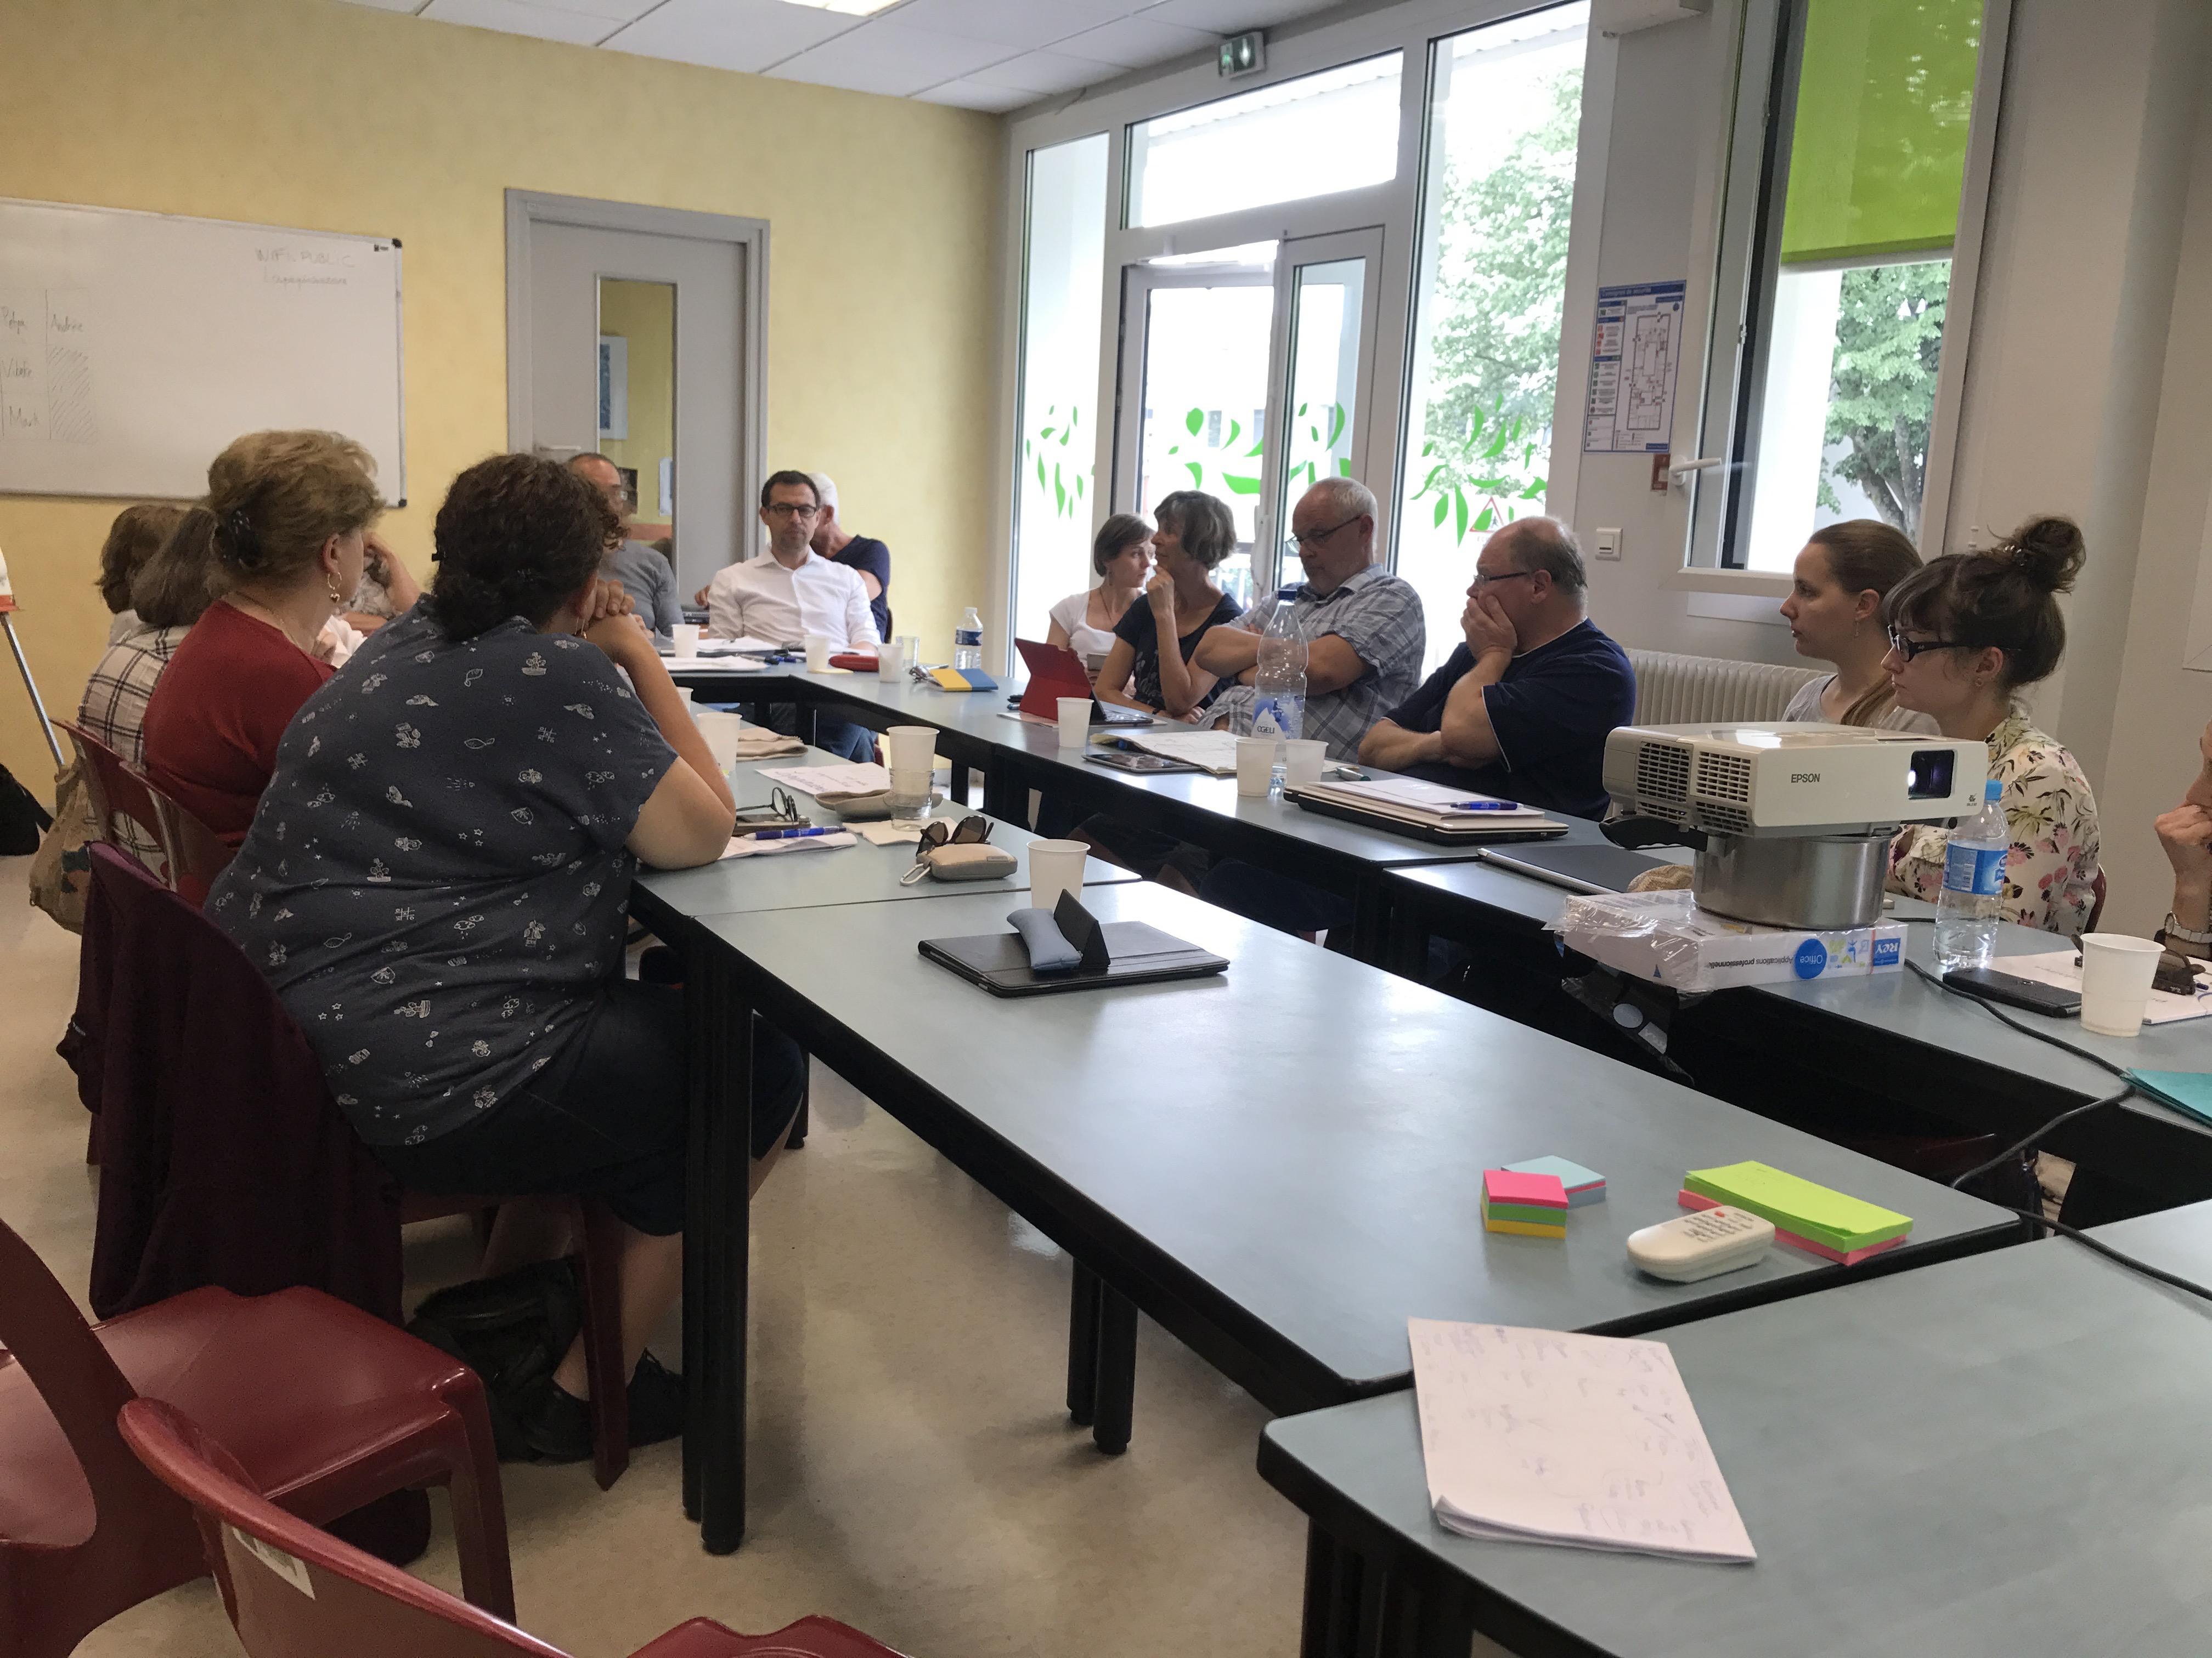

6. Jan explains the definition of social change brokering from the definition in the Practical Guide
Brokering means negotiations. Reflecting on the needs. Talking to people that knows something about these needs. We have not seen a person that has done that in our community before. We haven’t seen seniors in this role before.
We are not in the educational world; we are talking about real life.

We also wanted to get away from the social enterprise. We wanted to get away from the old entrepreneurship.

Moira: The term is important, because it is ageless compared to “Senior Social Entrepreneuring”.

7. Discussion about documentation
The seniors were not fund of the documentation part in the project. Mostly it was about the portfolios and not the videos. The seniors are ready to start up projects and look forward to share their experiences. However, a lot of the seniors aren’t ready for the documentation. We decided to discuss the portfolios Thursday, because it is a very important issue, which needs to be addressed.

Day 4 – Seminar, Thursday the 18th of May

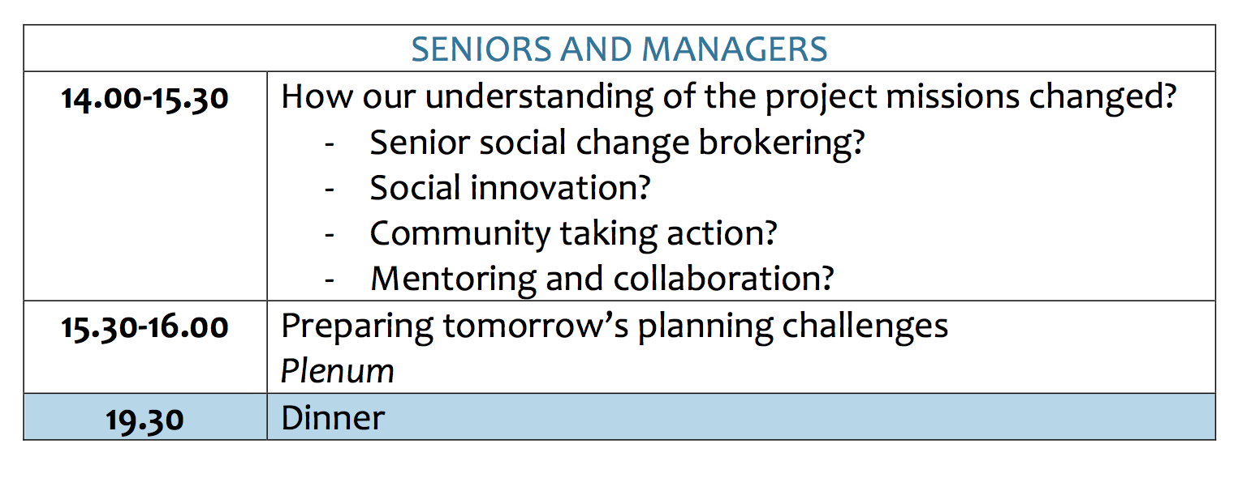

1. Brief presentation of the PP’s decision on the portfolio
“Practice Partners is responsible for getting information from the seniors on a regular basis and translating it, mainly by summarising it in the templates provided by the knowledge partner, into something workable for E-Seniors, the knowledge partner and the project in general”.
All seniors are okay with this decision.
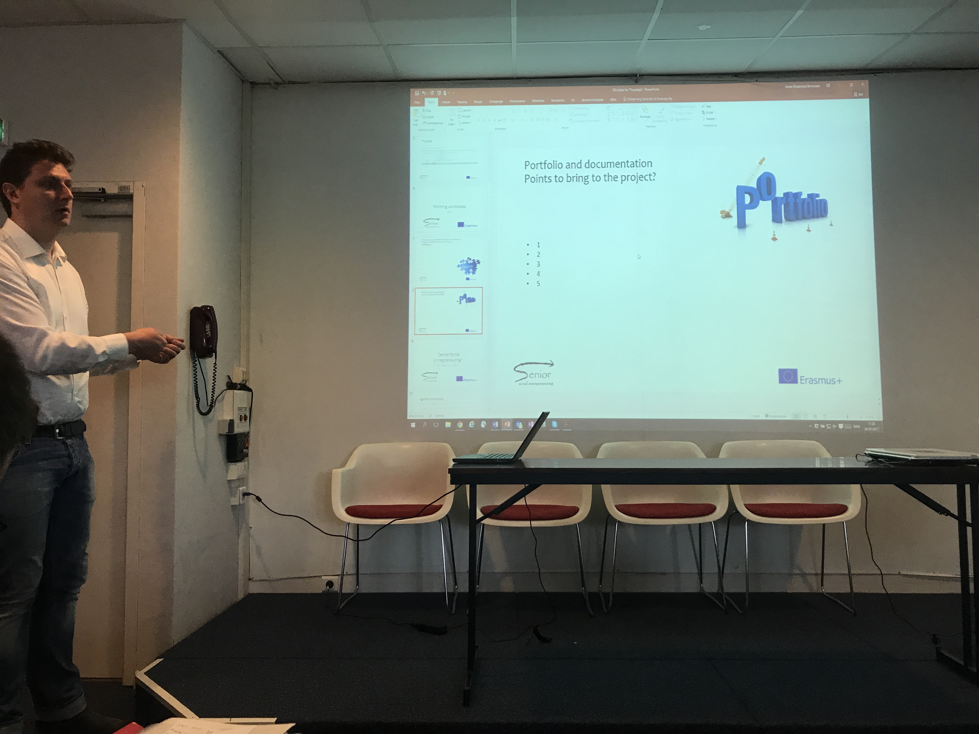
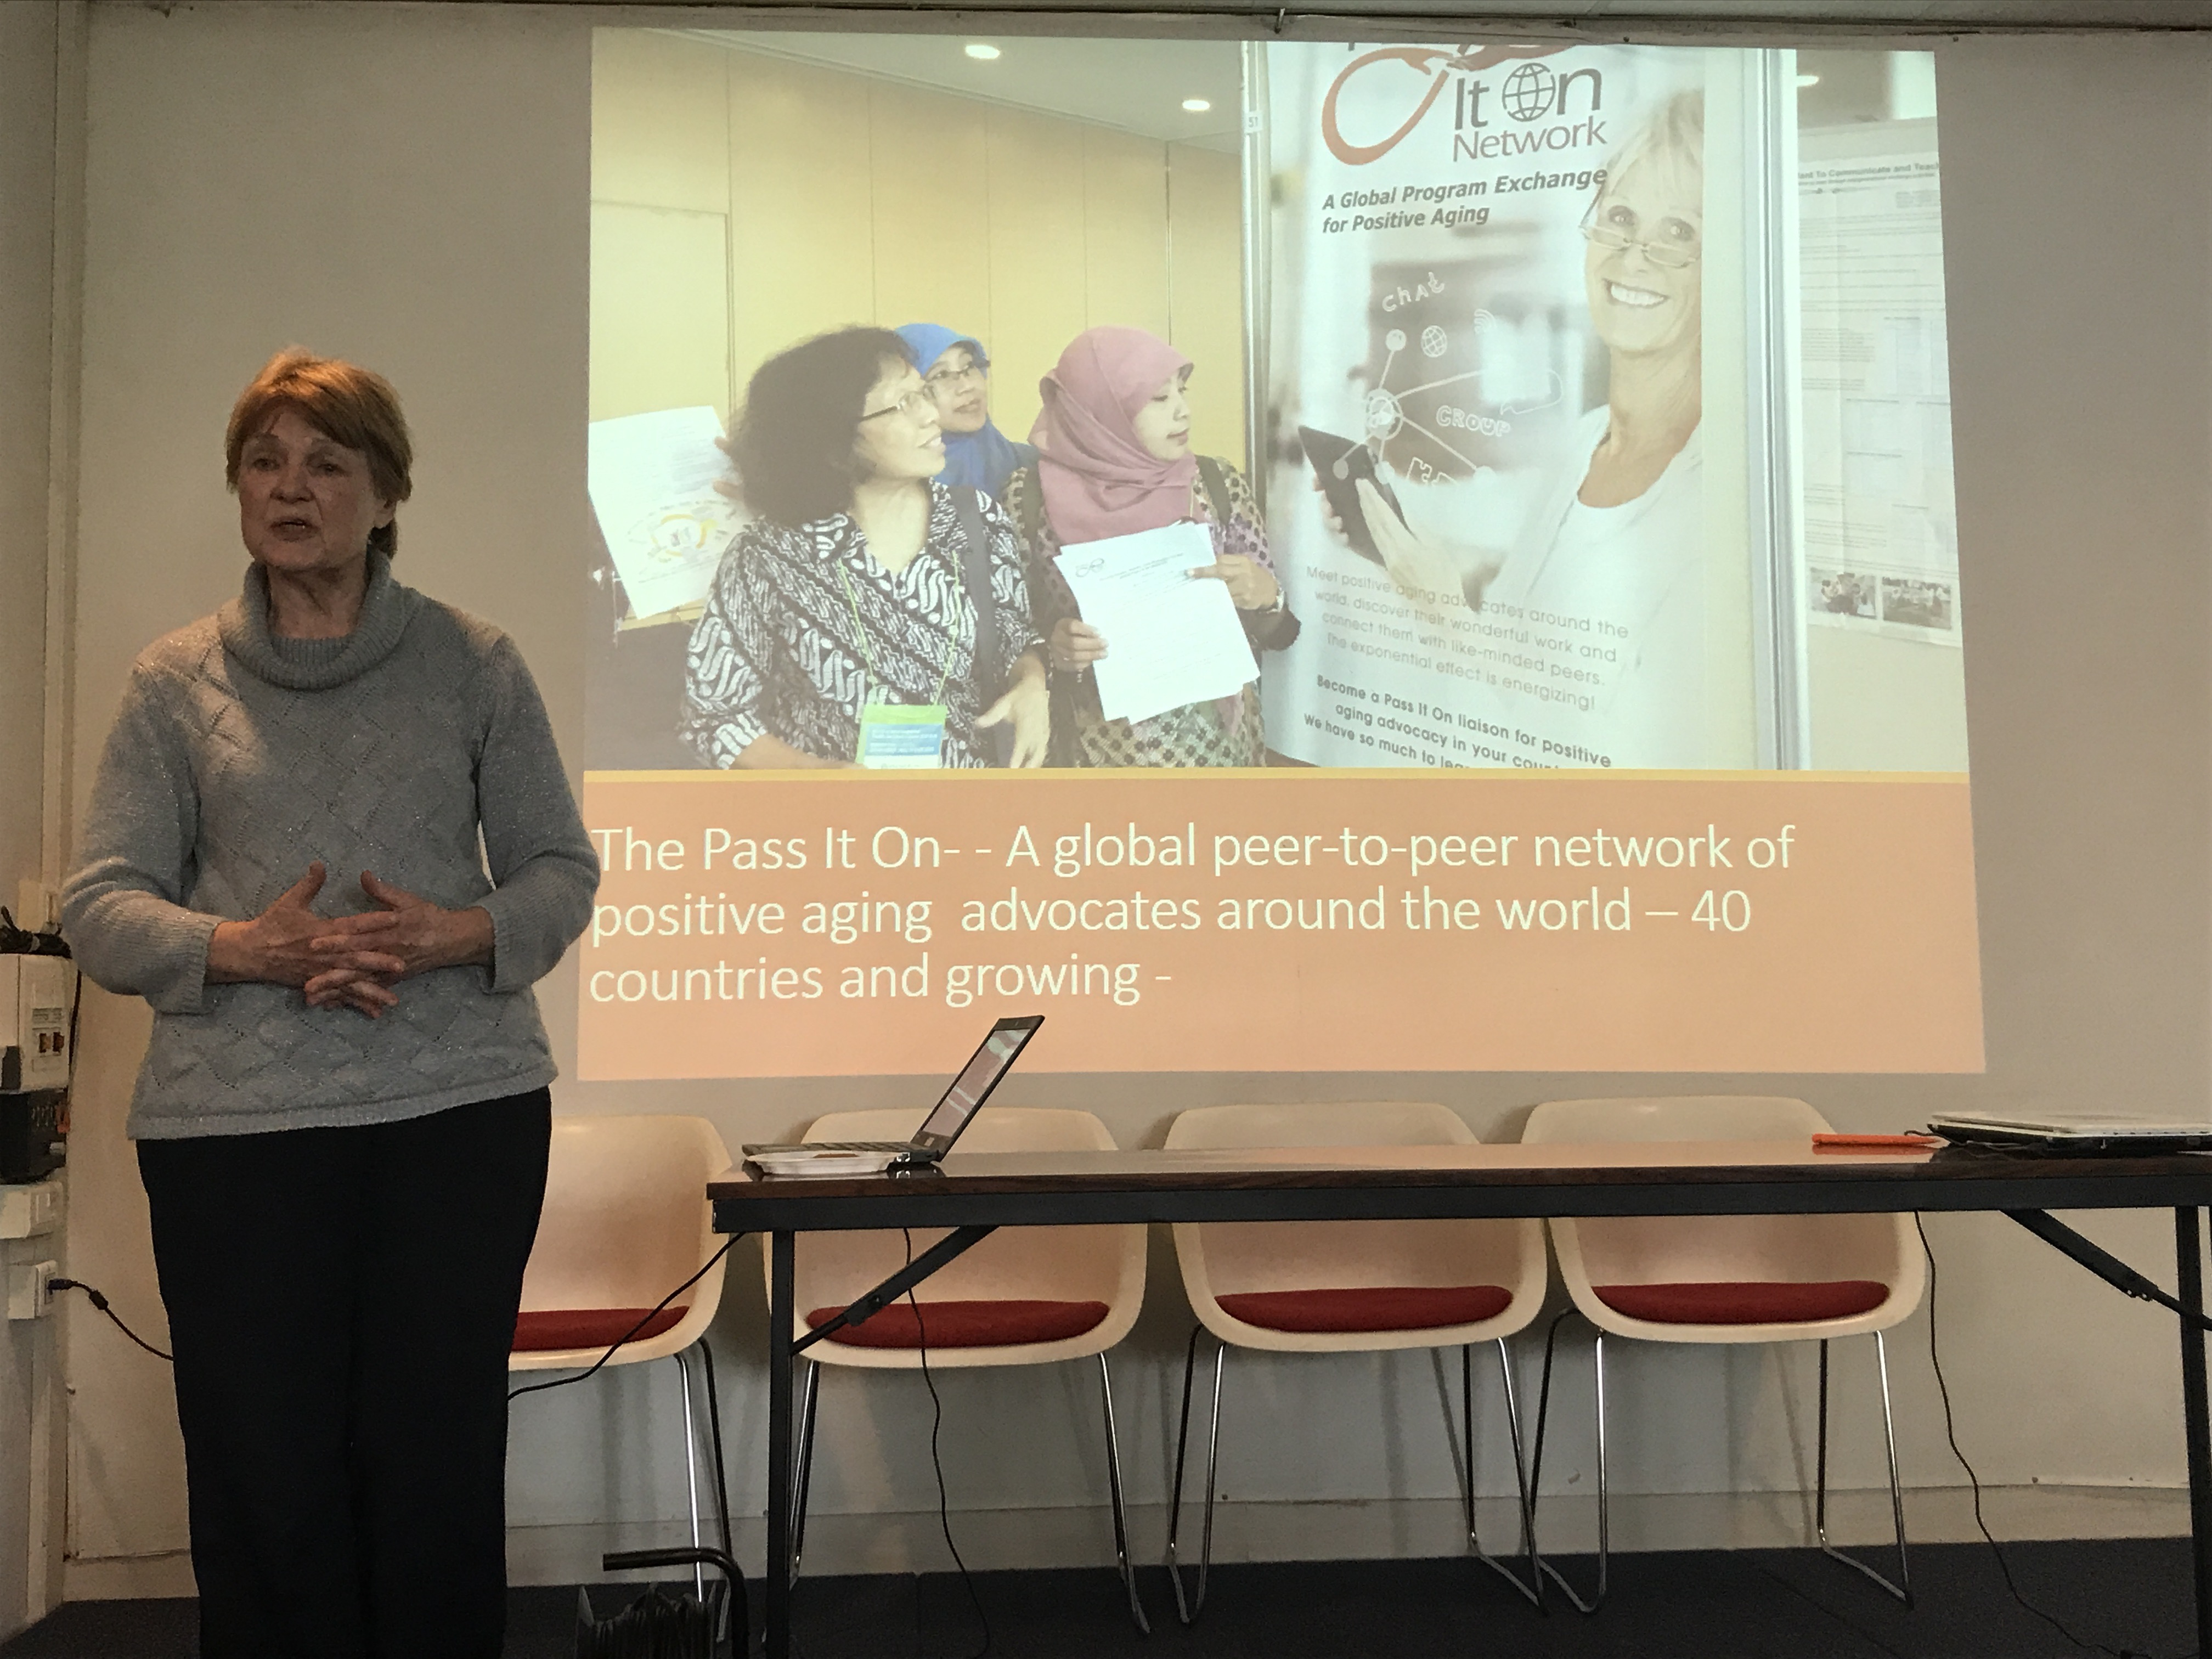

2. How our understanding of the project missions changed?
Jesper asks the seniors and partners, if their understanding of the project missions has changed. A senior doesn’t quite understand the mentoring term.
Another senior is mentioning the issue with documentation and portfolio. The senior thinks it’s all partners’ challenge and not the seniors.
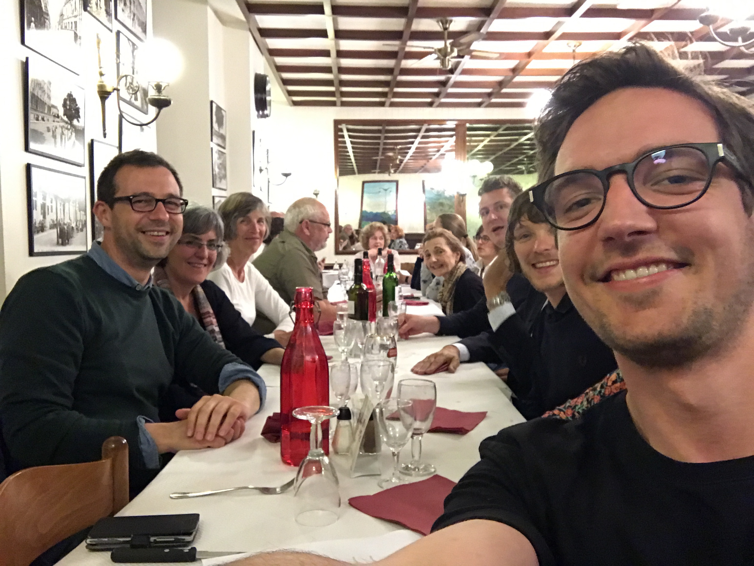
Jan says that Senior Social Change Brokering isn’t something we can’t understand yet; because it is a new term we came up with.

Day 5 – Seminar, Friday the 19th of May
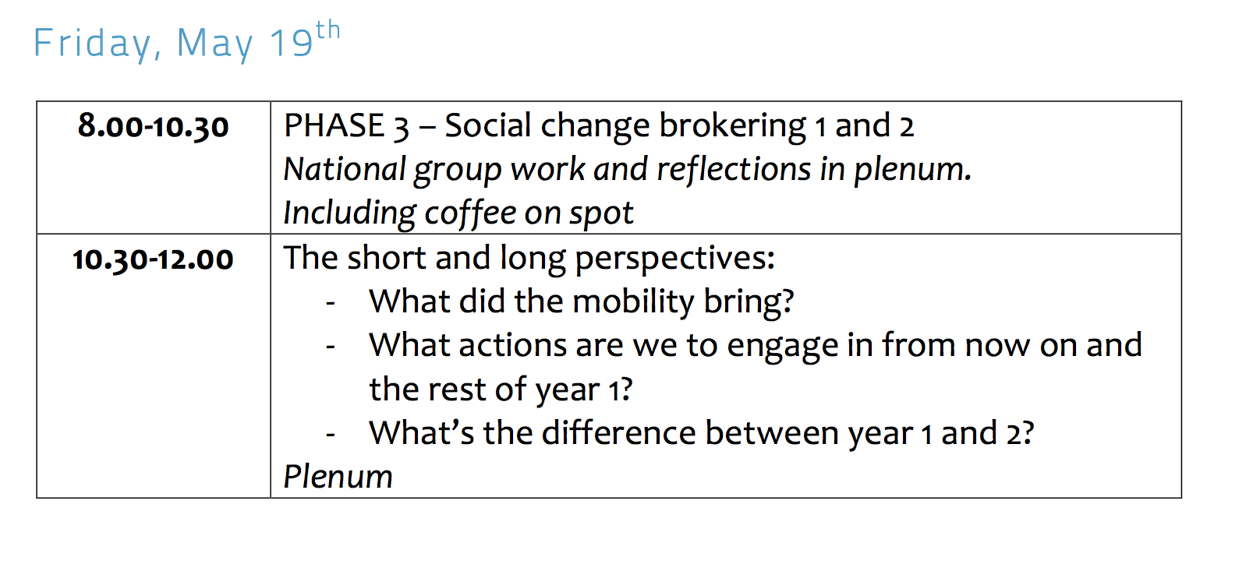

1. The seniors thoughts about this seminar

Marks thoughts of the week:
Mark mentioned that he learned what the project is about and that it has been a good experience. He wants to say a big thank you to the coordinator, who he thinks has done a good job.

Moiras thoughts of the week:
Moira wants to say something. We as seniors should help with the bottom-up model and she has learned a lot about this from Chester University (Shropshire/Shrewsbury).
Moira likes the term senior social change broker and if we don’t understand it today, it’s because the term is new and it will be defined throughout the project.
One of the super things that could come out of this project is to look at the county of Shrewsbury. What has been taken away from you and what has grown up by the local community?
What is a volunteer and what is a social change broker? We need to understand the difference.
She looks forward to a network of pioneers and social change brokering.

This is what Edith learned this week:
There is confusing in the definition of the social entrepreneuring. I’m gonna share it with you. The words are very important. They have a meaning. We saw it with the word brokering. Even the English has problems with it. So you really need to be precise.

We have a huge responsibility to the younger people. We have made the world they live in. We have the responsibility to tell the young people our experience, stories and failures. We have to be open to the young people and their ideas.
Together we are much stronger.
We shouldn’t be afraid of our imagination.
The third age is a perfect time to become a full citizen.

Nadya wanted to sum up:
It is good to be here and see people who want change. Trying to change the mindset in the county. We have now a more clear view of the practice.

That was it for the 5 days seminar.

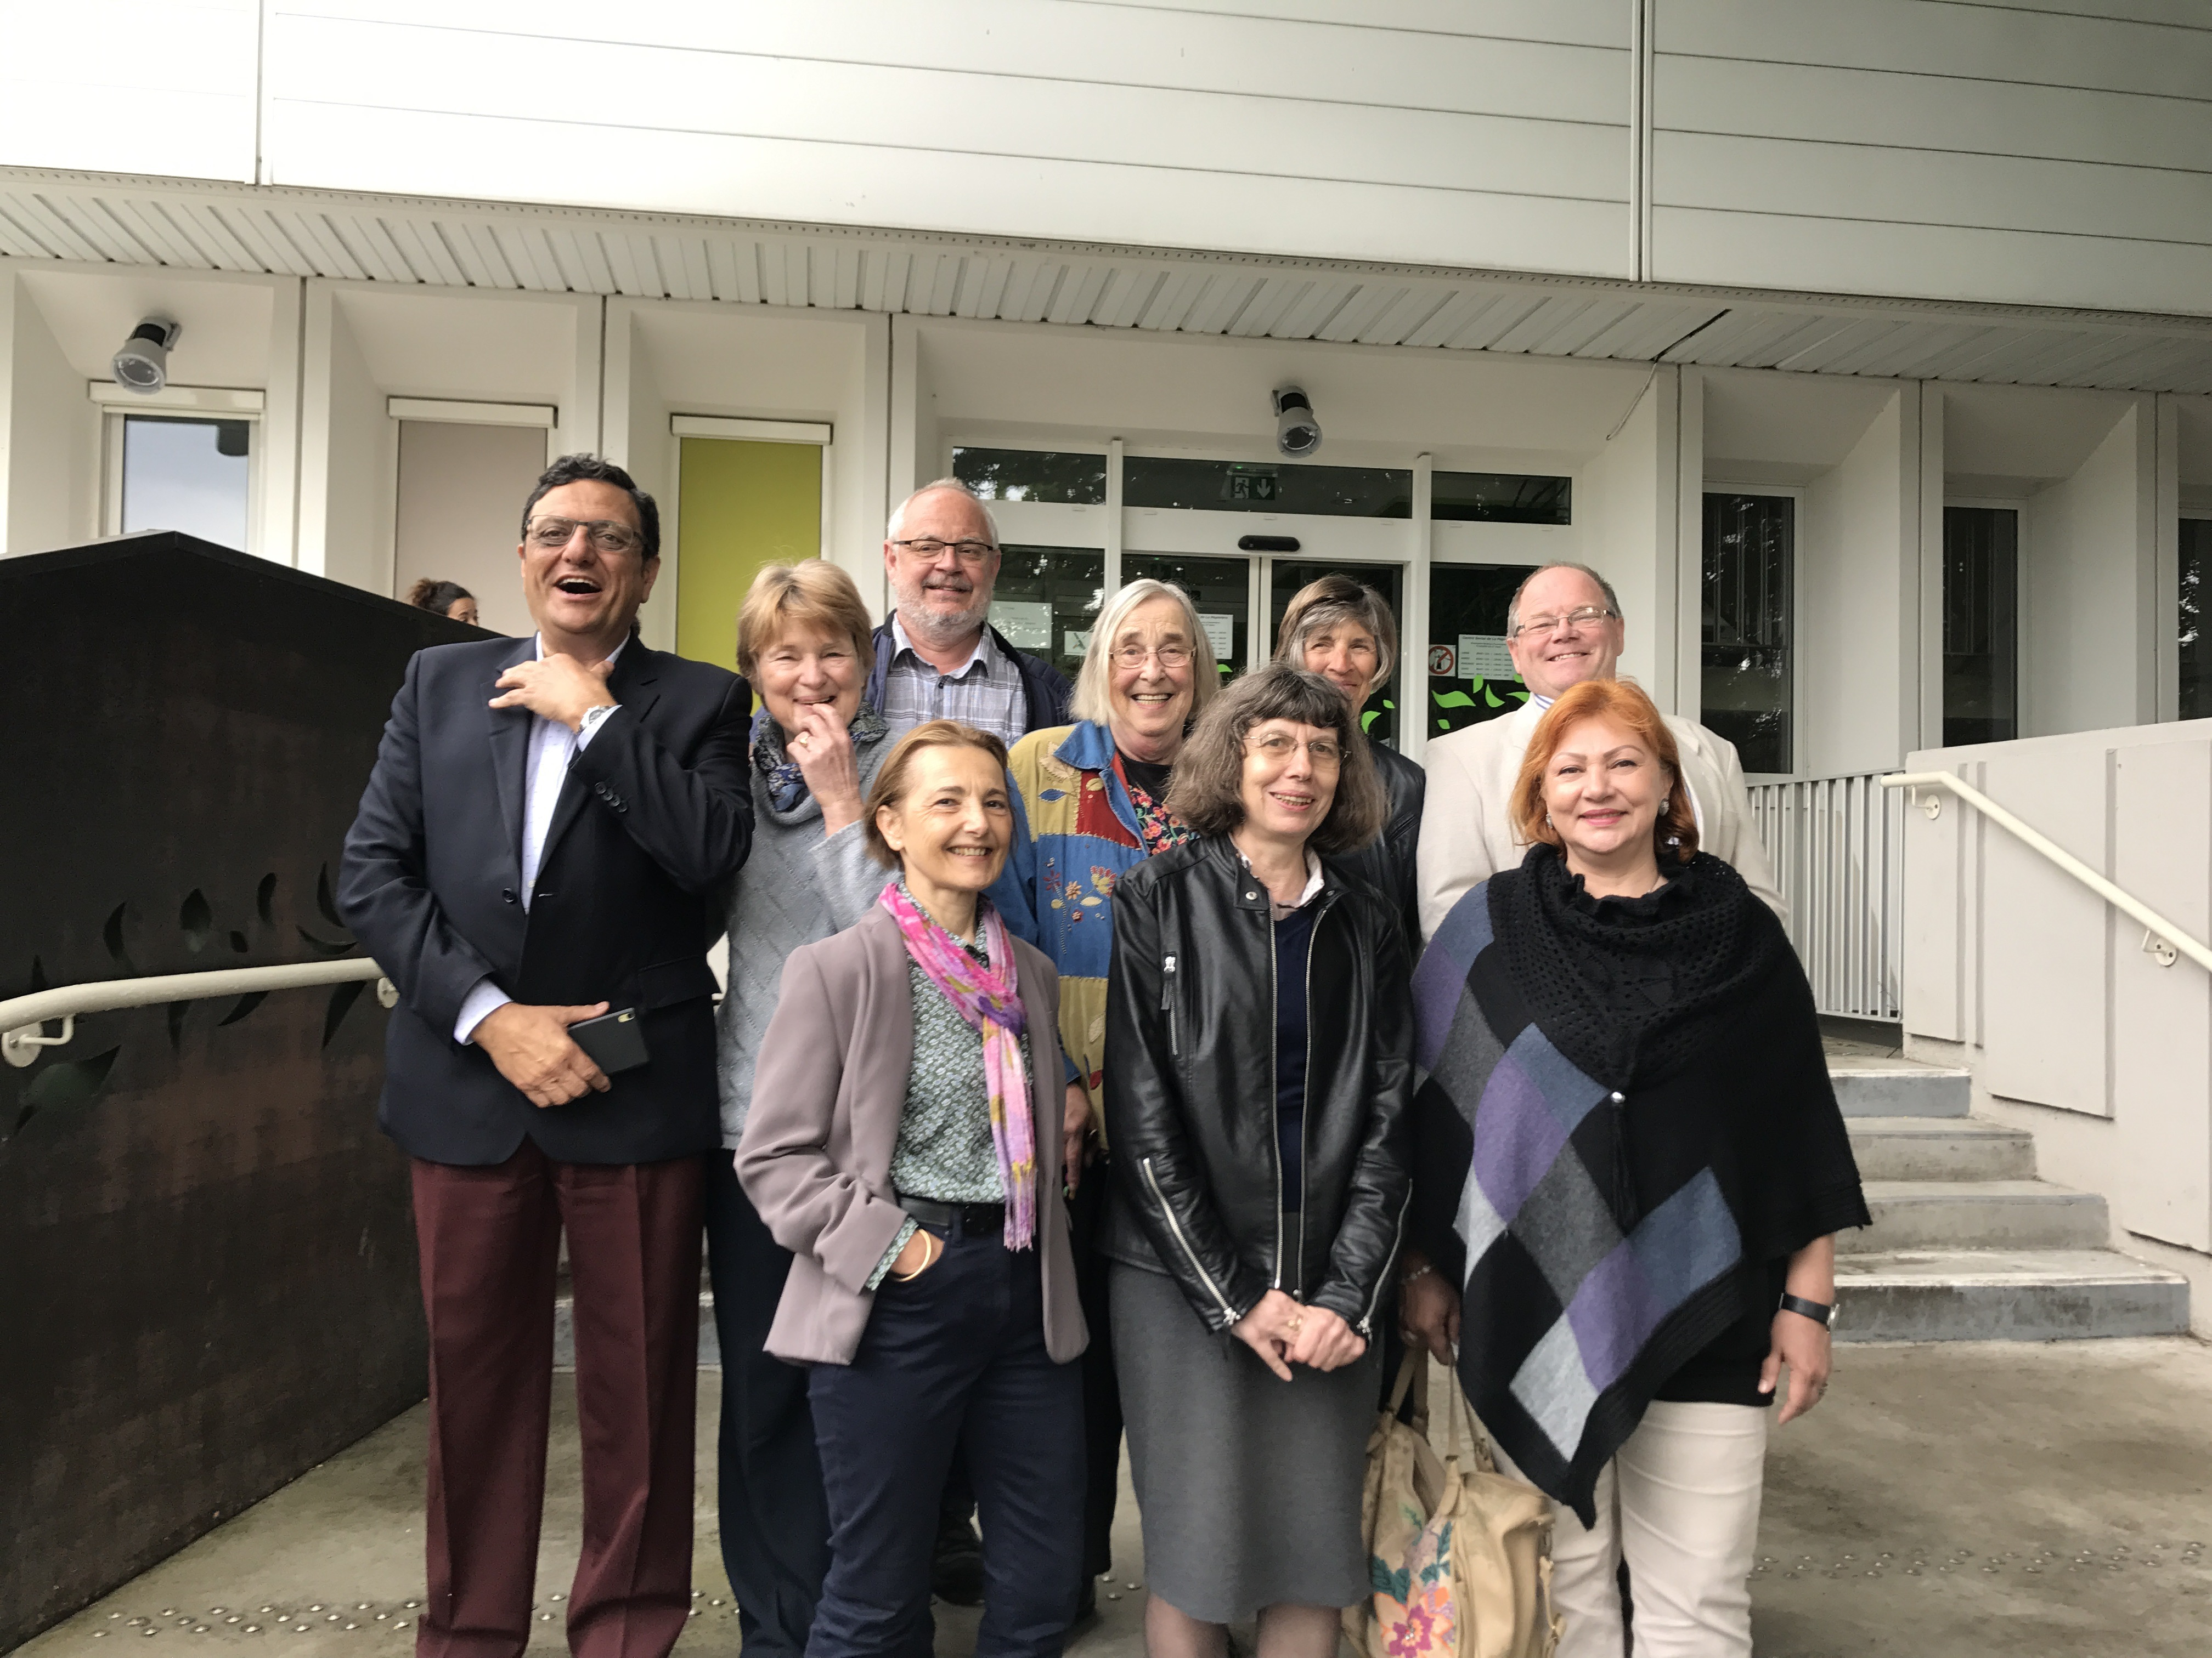
Thanks for a great seminar to our participants. Hopefully we will meet them again

